Lecture 11:

CNNs in Practice



Fei-Fei Li & Andrej Karpathy & Justin Johnson Lecture 11 1 17 Feb 2016

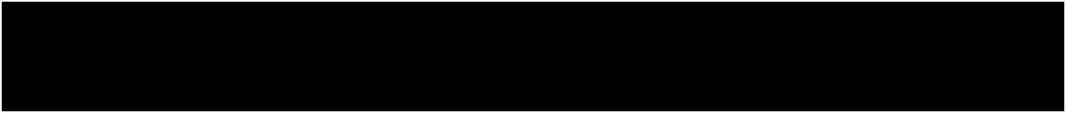Administrative



* Midterms are graded!
  + Pick up now
  + Or in Andrej, Justin, Albert, or Serena’s OH
* Project milestone due today, 2/17 by midnight
  + Turn in to Assignments tab on Coursework!
* Assignment 2 grades soon
* Assignment 3 released, due 2/24



Fei-Fei Li & Andrej Karpathy & Justin Johnson Lecture 11 2 17 Feb 2016

Midterm stats

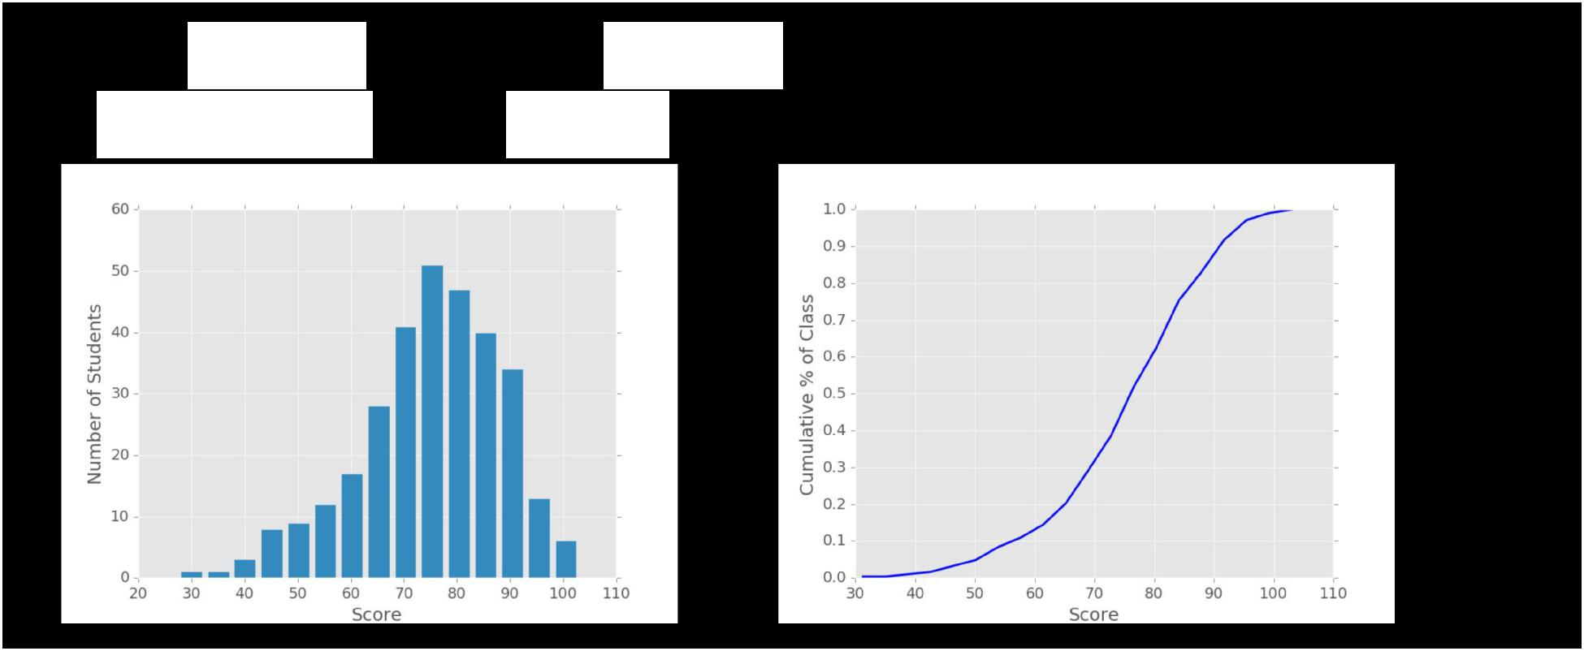

**Mean:** 75.0 **Median:** 76.3 **Standard Deviation:** 13.2

**N:** 311 **Max:** 103.0



Fei-Fei Li & Andrej Karpathy & Justin Johnson Lecture 11 3 17 Feb 2016

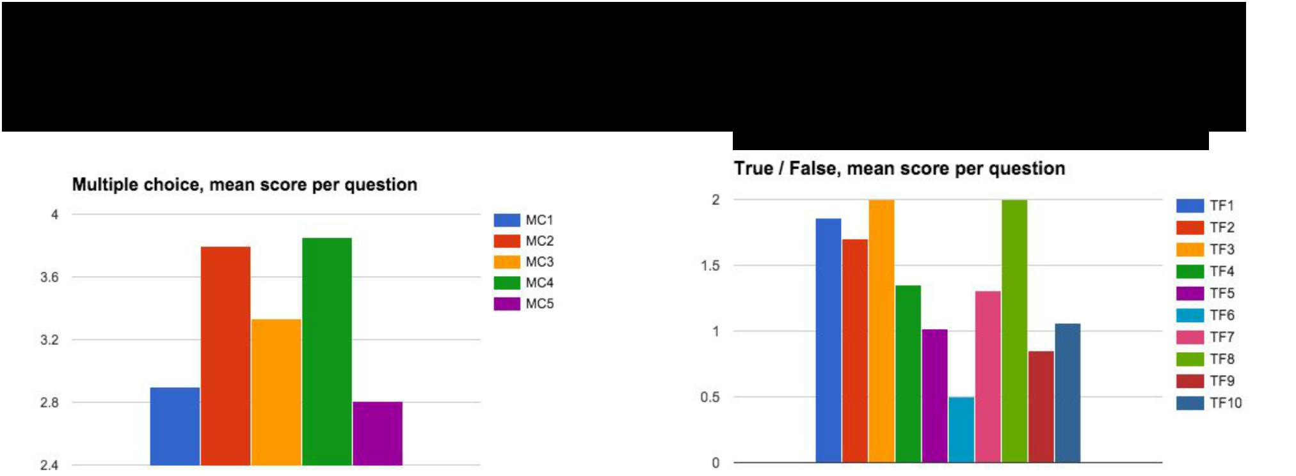Midterm stats

[We threw out TF3 and TF8]



Fei-Fei Li & Andrej Karpathy & Justin Johnson Lecture 11 4 17 Feb 2016

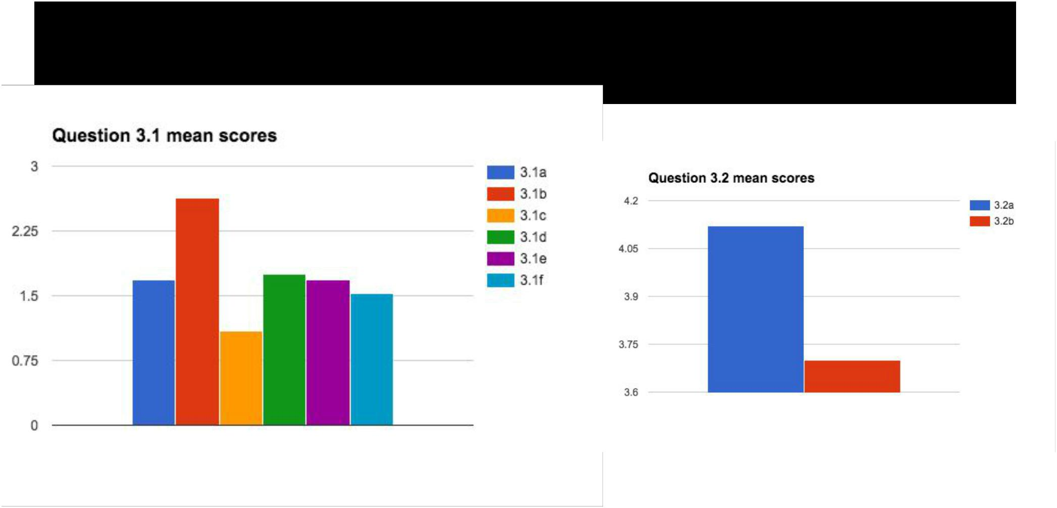Midterm stats



Fei-Fei Li & Andrej Karpathy & Justin Johnson Lecture 11 5 17 Feb 2016

Midterm Stats

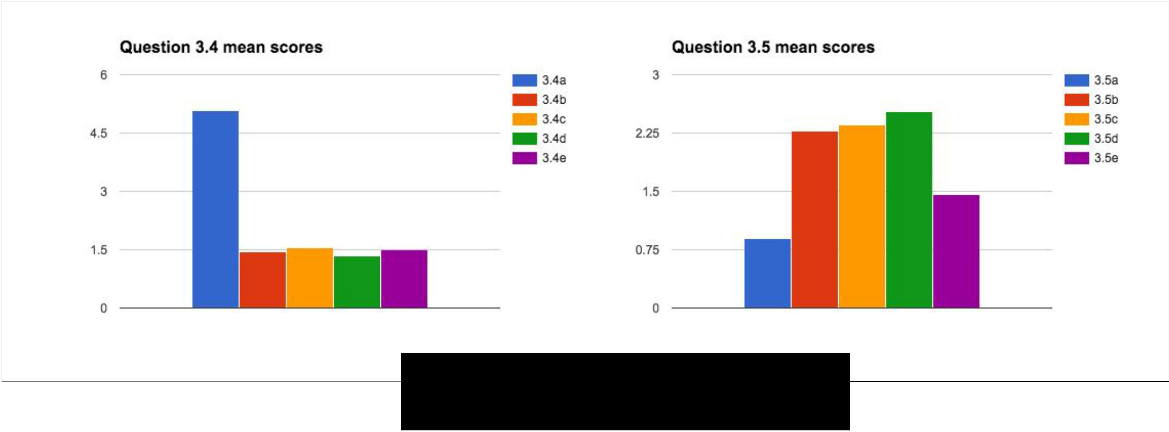

**Bonus mean:** 0.8



Fei-Fei Li & Andrej Karpathy & Justin Johnson Lecture 11 6 17 Feb 2016

Last Time

Vanilla RNNs

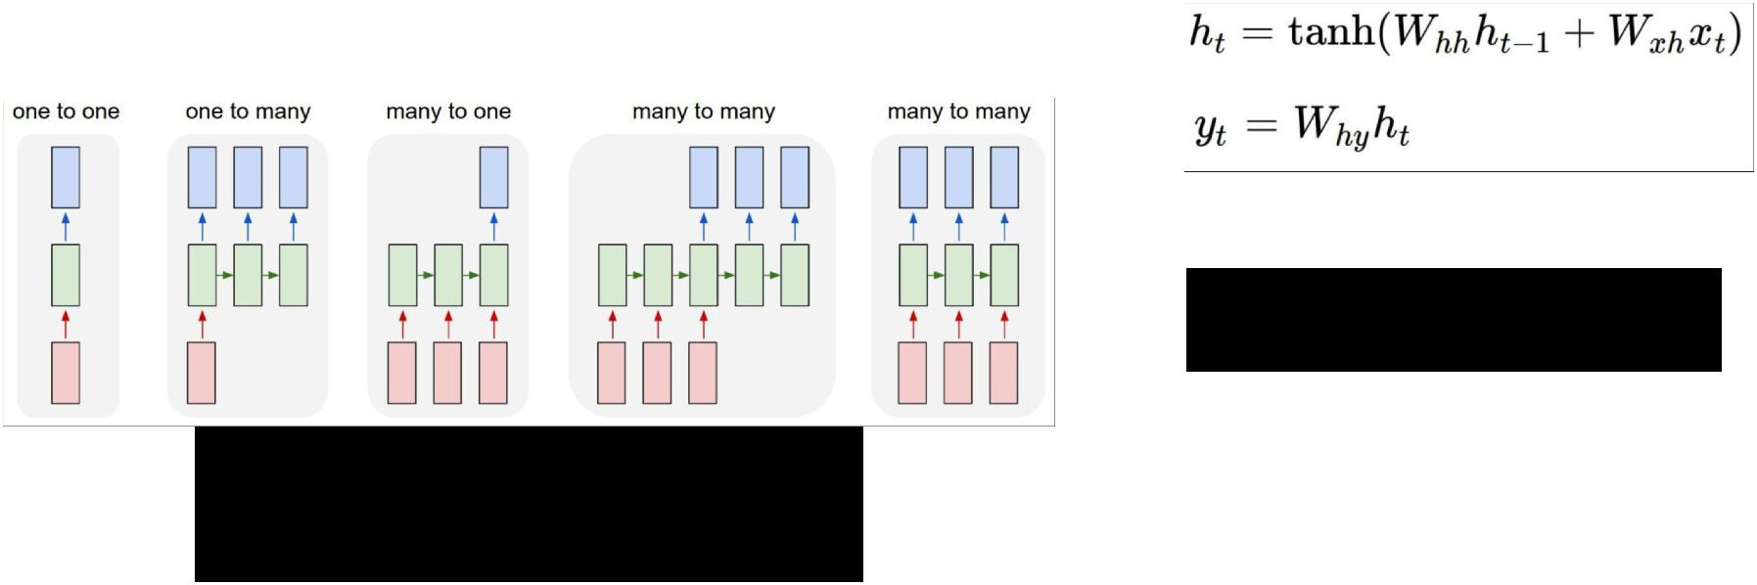

LSTMs

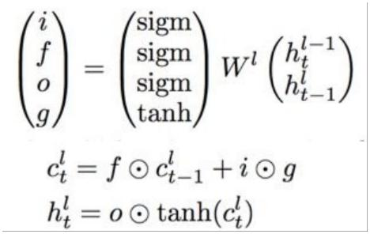

Recurrent neural networks

for modeling sequences



Fei-Fei Li & Andrej Karpathy & Justin Johnson Lecture 11 7 17 Feb 2016

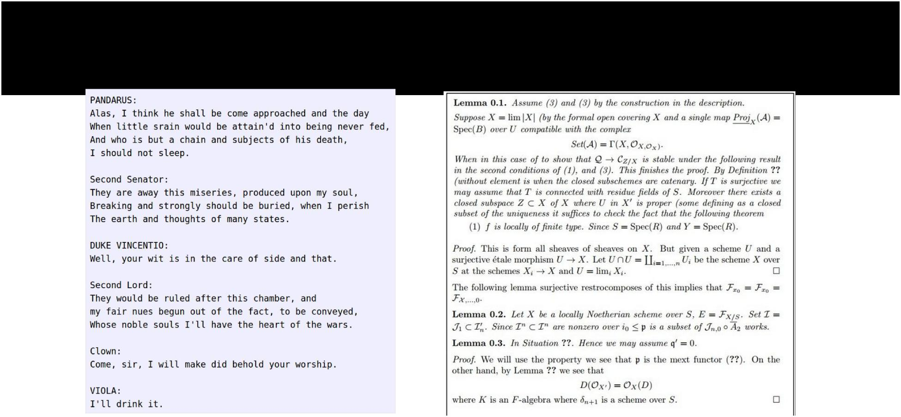

Last Time



Sampling from RNN language models to generate text



|  |  |  |
| --- | --- | --- |
| Fei-Fei Li & Andrej Karpathy & Justin Johnson | Lecture 11 8 | 17 Feb 2016 |
|  |  |  |

Last Time

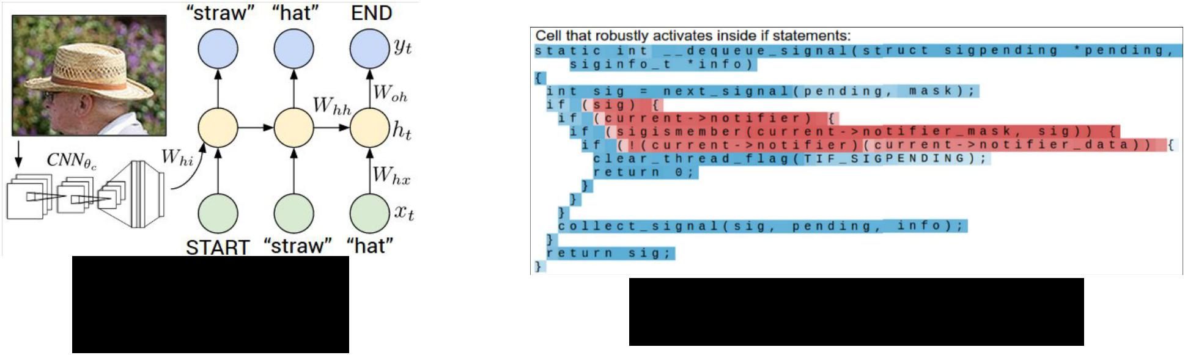

|  |  |  |
| --- | --- | --- |
| CNN + RNN for | Interpretable RNN cells |  |
| image captioning |  |
|  |  |



Fei-Fei Li & Andrej Karpathy & Justin Johnson Lecture 11 9 17 Feb 2016

Today

Working with CNNs in practice:

* Making the most of your data
  + Data augmentation
  + Transfer learning
* All about convolutions:
  + How to arrange them
  + How to compute them fast
* “Implementation details”
  + GPU / CPU, bottlenecks, distributed training



Fei-Fei Li & Andrej Karpathy & Justin Johnson Lecture 11 10 17 Feb 2016

Data Augmentation



Fei-Fei Li & Andrej Karpathy & Justin Johnson Lecture 11 11 17 Feb 2016

Data Augmentation

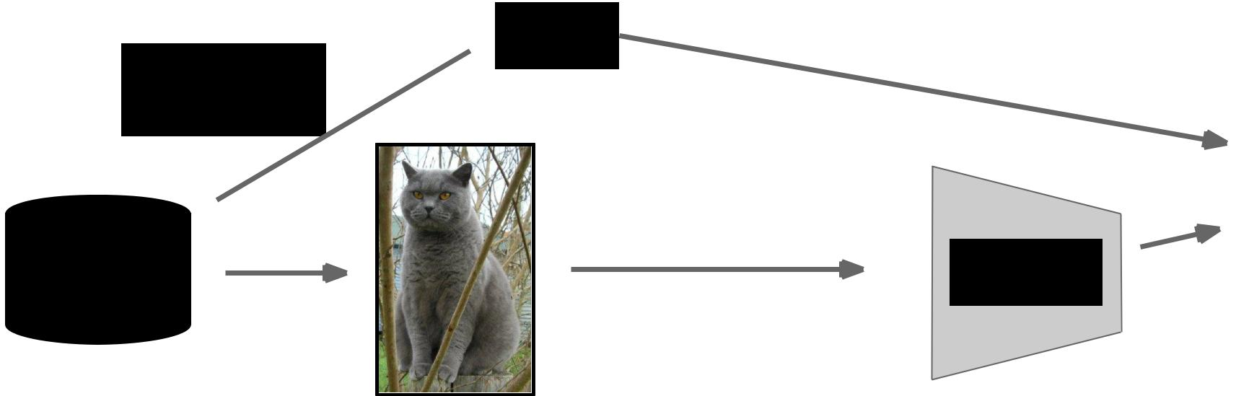

Load image

and label



 “cat”

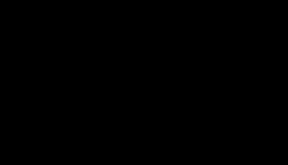

Compute

loss

CNN



Fei-Fei Li & Andrej Karpathy & Justin Johnson Lecture 11 12 17 Feb 2016

Data Augmentation

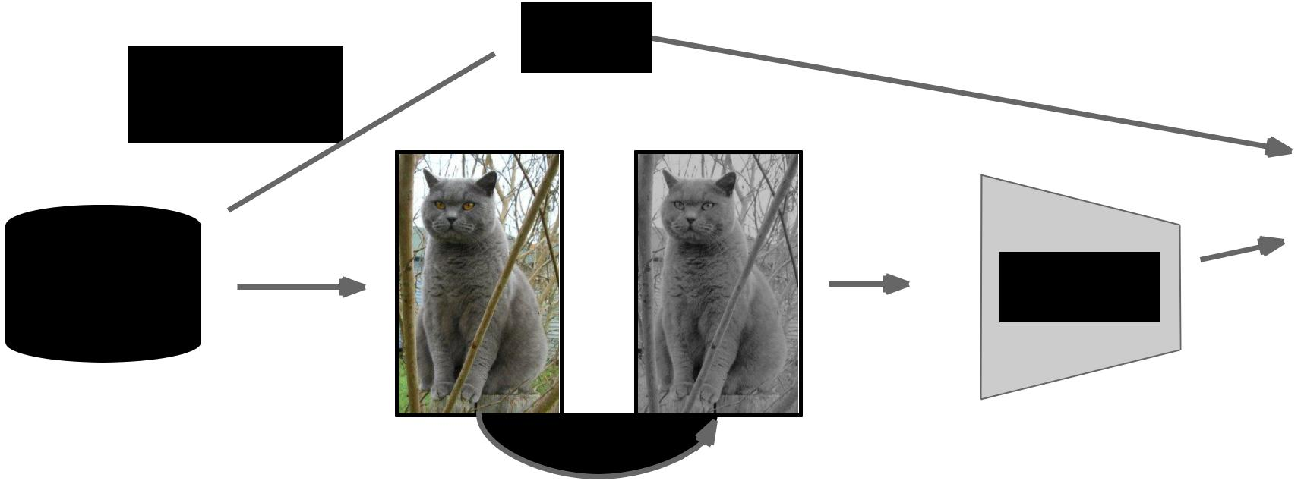

Load image

and label



 “cat”



Compute

loss

CNN



Transform image



Fei-Fei Li & Andrej Karpathy & Justin Johnson Lecture 11 13 17 Feb 2016

**Data Augmentation**

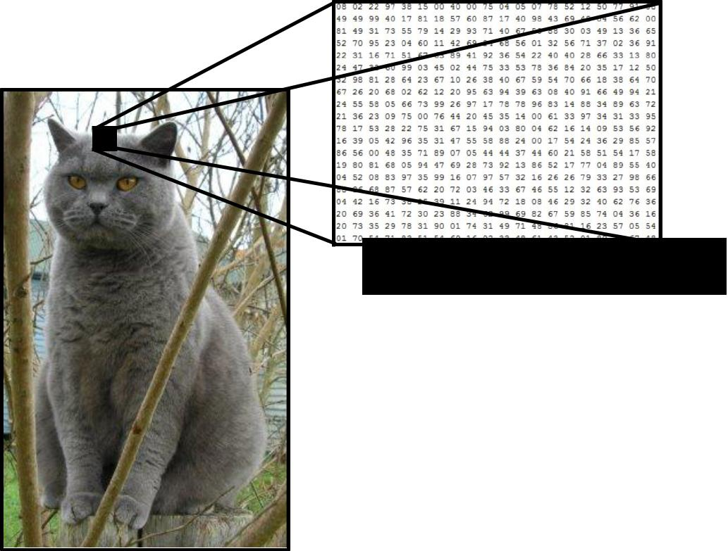

- Change the pixels without changing the label

What the computer sees

* Train on transformed data
* VERY widely used



Fei-Fei Li & Andrej Karpathy & Justin Johnson Lecture 11 14 17 Feb 2016

**Data Augmentation**

1. Horizontal flips

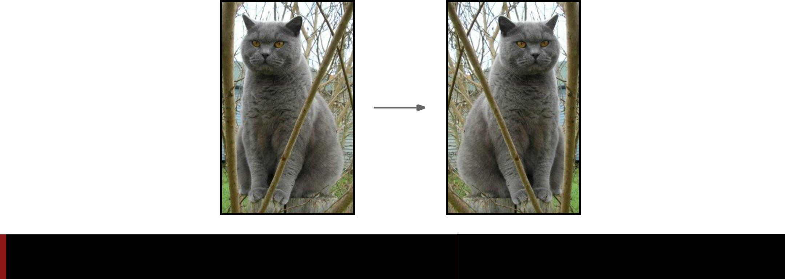

Fei-Fei Li & Andrej Karpathy & Justin Johnson Lecture 11 15 17 Feb 2016

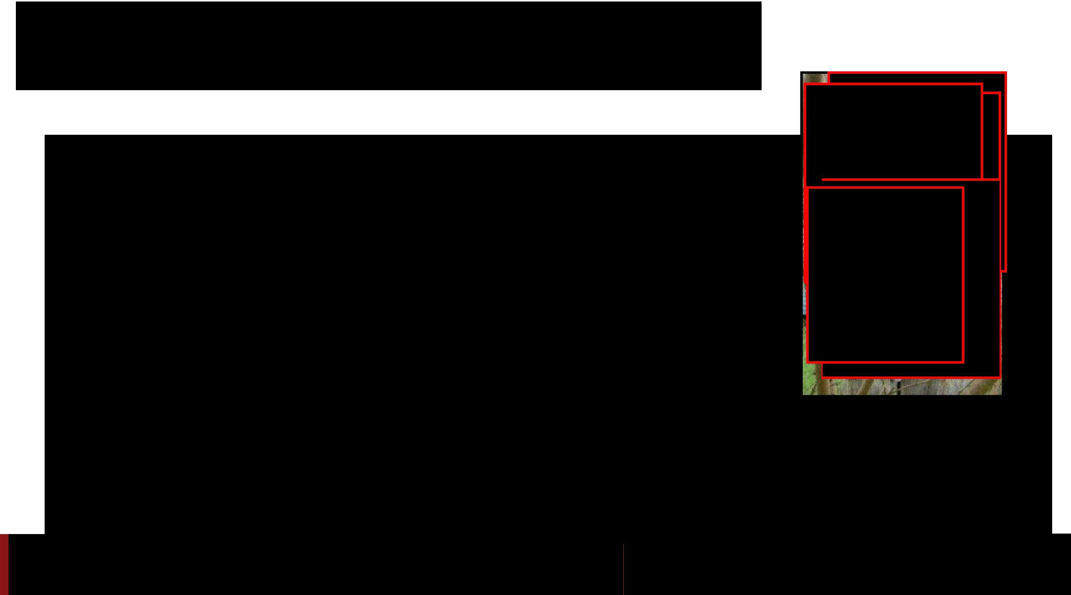**Data Augmentation**

2. Random crops/scales

**Training**: sample random crops / scales

Fei-Fei Li & Andrej Karpathy & Justin Johnson Lecture 11 16 17 Feb 2016

**Data Augmentation**

2. Random crops/scales

**Training**: sample random crops / scales

ResNet:

1. Pick random L in range [256, 480]
2. Resize training image, short side = L
3. Sample random 224 x 224 patch

Fei-Fei Li & Andrej Karpathy & Justin Johnson Lecture 11 17 17 Feb 2016

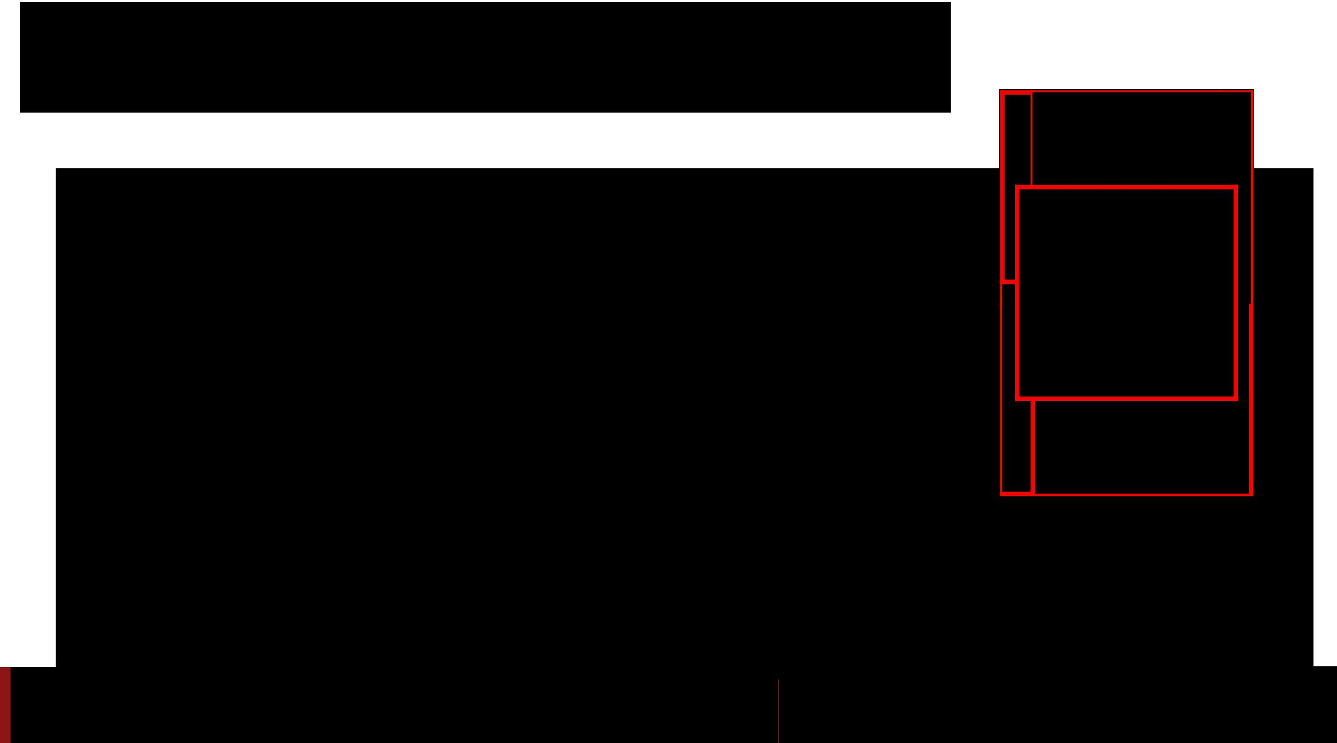**Data Augmentation**

2. Random crops/scales

**Training**: sample random crops / scales

ResNet:

1. Pick random L in range [256, 480]
2. Resize training image, short side = L
3. Sample random 224 x 224 patch

**Testing**: average a fixed set of crops

Fei-Fei Li & Andrej Karpathy & Justin Johnson Lecture 11 18 17 Feb 2016

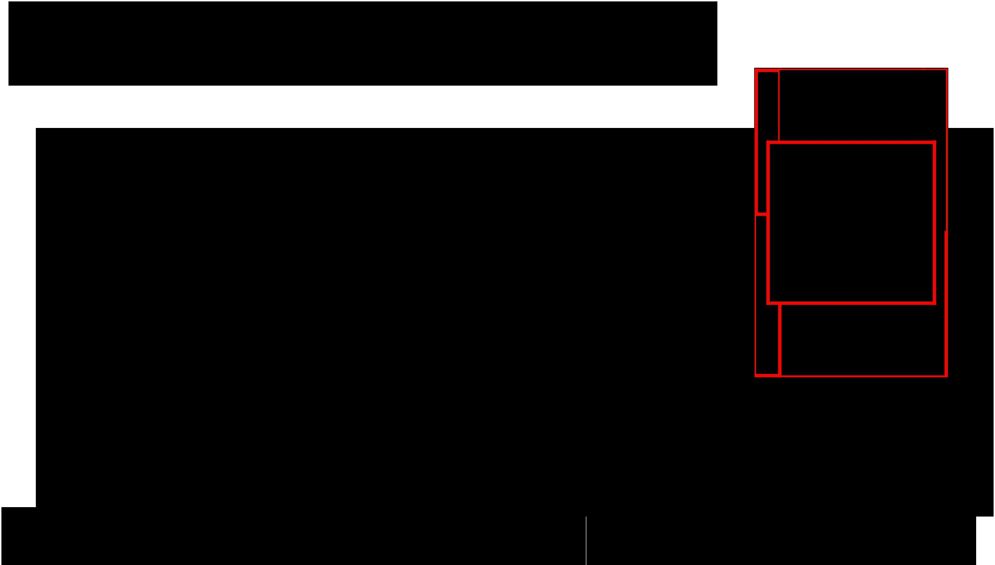

**Data Augmentation**

2. Random crops/scales

**Training**: sample random crops / scales

ResNet:

1. Pick random L in range [256, 480]
2. Resize training image, short side = L
3. Sample random 224 x 224 patch

**Testing**: average a fixed set of crops

ResNet:

1. Resize image at 5 scales: {224, 256, 384, 480, 640}
2. For each size, use 10 224 x 224 crops: 4 corners + center, + flips

|  |  |  |
| --- | --- | --- |
| Fei-Fei Li & Andrej Karpathy & Justin Johnson | Lecture 11 19 | 17 Feb 2016 |
|  |  |  |

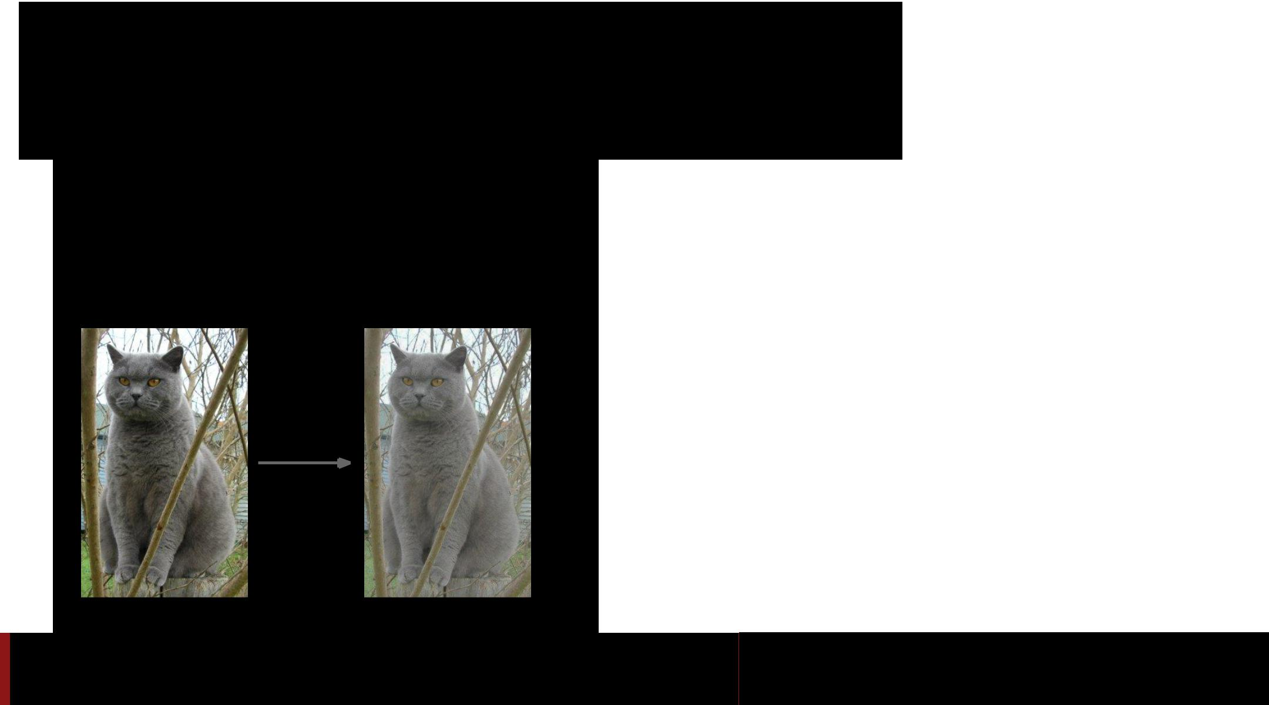**Data Augmentation**

3. Color jitter

**Simple**:

Randomly jitter contrast



Fei-Fei Li & Andrej Karpathy & Justin Johnson Lecture 11 20 17 Feb 2016

**Data Augmentation** 3. Color jitter

**Simple**:

Randomly jitter contrast



**Complex**:

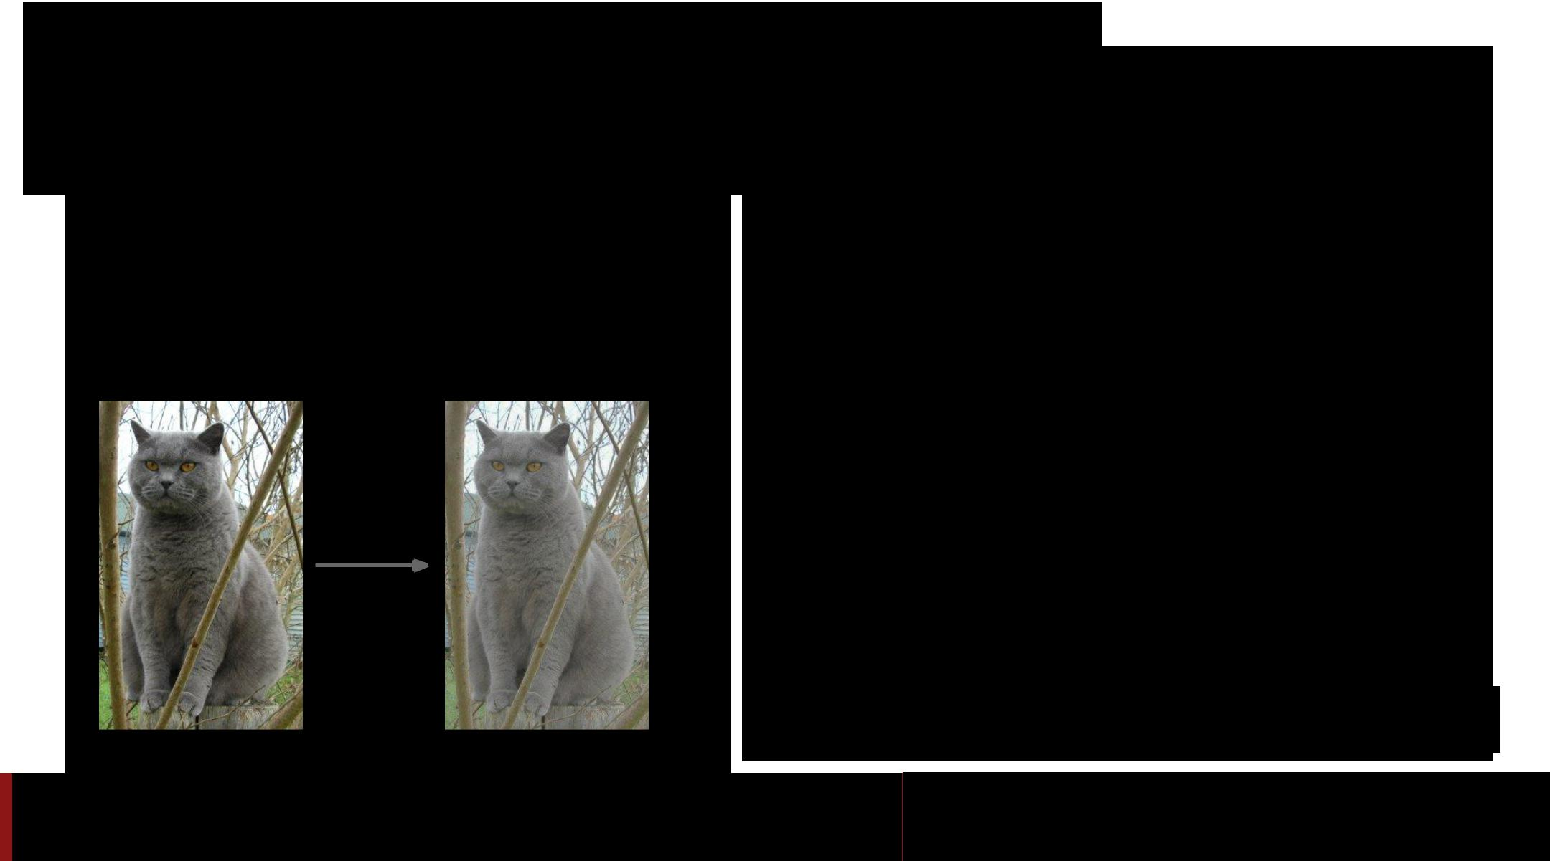

1. Apply PCA to all [R, G, B] pixels in training set
2. Sample a “color offset” along principal component directions
3. Add offset to all pixels of a training image

(As seen in *[Krizhevsky et al. 2012],* ResNet, etc)

Fei-Fei Li & Andrej Karpathy & Justin Johnson Lecture 11 21 17 Feb 2016

**Data Augmentation**

4. Get creative!



Random mix/combinations of :

* translation
* rotation
* stretching
* shearing,
* lens distortions, … (go crazy)



Fei-Fei Li & Andrej Karpathy & Justin Johnson Lecture 11 22 17 Feb 2016



**A general theme:**

1. **Training**: Add random noise
2. **Testing**: Marginalize over the noise

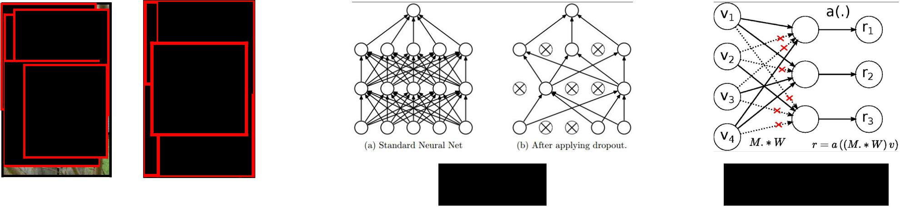

Dropout DropConnect

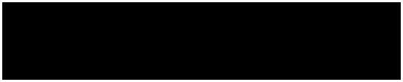

Data Augmentation



Batch normalization, Model ensembles



|  |  |  |
| --- | --- | --- |
| Fei-Fei Li & Andrej Karpathy & Justin Johnson | Lecture 11 23 | 17 Feb 2016 |
|  |  |  |

Data Augmentation: Takeaway



* Simple to implement, use it
* Especially useful for small datasets
* Fits into framework of noise / marginalization



Fei-Fei Li & Andrej Karpathy & Justin Johnson Lecture 11 24 17 Feb 2016

Transfer Learning

“You need a lot of a data if you want to

train/use CNNs”



Fei-Fei Li & Andrej Karpathy & Justin Johnson Lecture 11 25 17 Feb 2016

Transfer Learning

“You need a lot want to



Fei-Fei Li & Andrej Karpathy & Justin Johnson Lecture 11 26 17 Feb 2016

Transfer Learning with CNNs

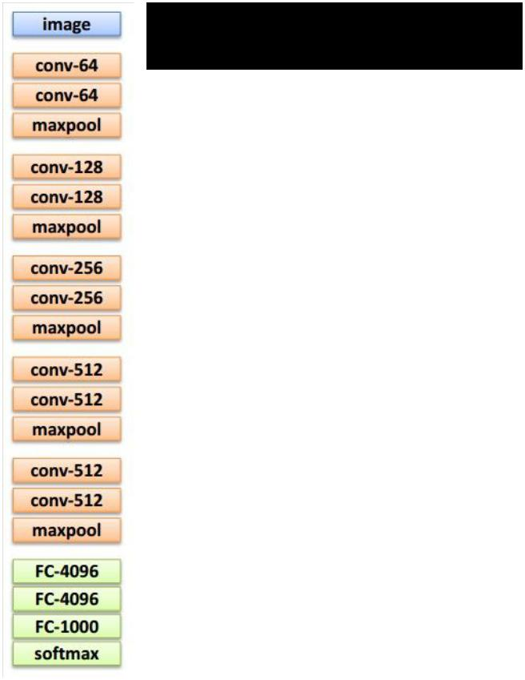

1. Train on Imagenet



Fei-Fei Li & Andrej Karpathy & Justin Johnson Lecture 11 27 17 Feb 2016

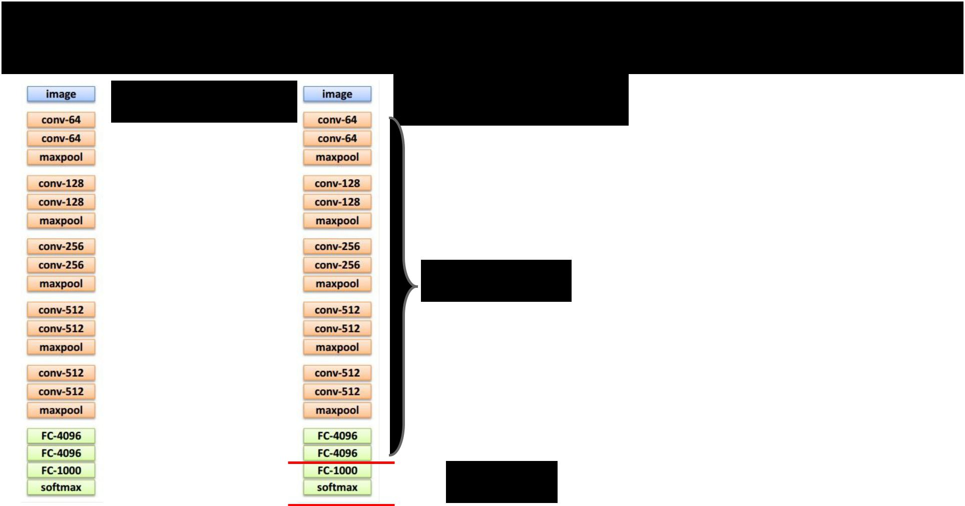Transfer Learning with CNNs

2. Small dataset:

1. Train on feature extractor

Imagenet

Freeze these

 Train this



Fei-Fei Li & Andrej Karpathy & Justin Johnson Lecture 11 28 17 Feb 2016

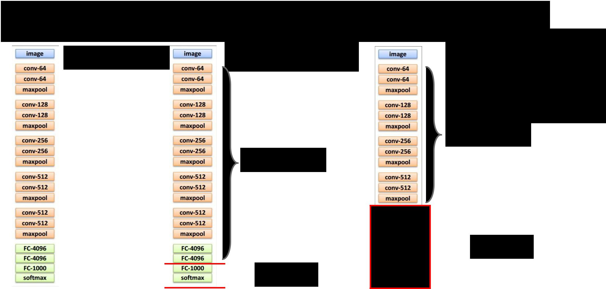Transfer Learning with CNNs

|  |  |
| --- | --- |
|  | 2. Small dataset: |
| 1. Train on | **feature extractor** |
| Imagenet |  |

Freeze these

 Train this



1. Medium dataset: **finetuning**

more data = retrain more of the network (or all of it)

Freeze these

 Train this



Fei-Fei Li & Andrej Karpathy & Justin Johnson Lecture 11 29 17 Feb 2016

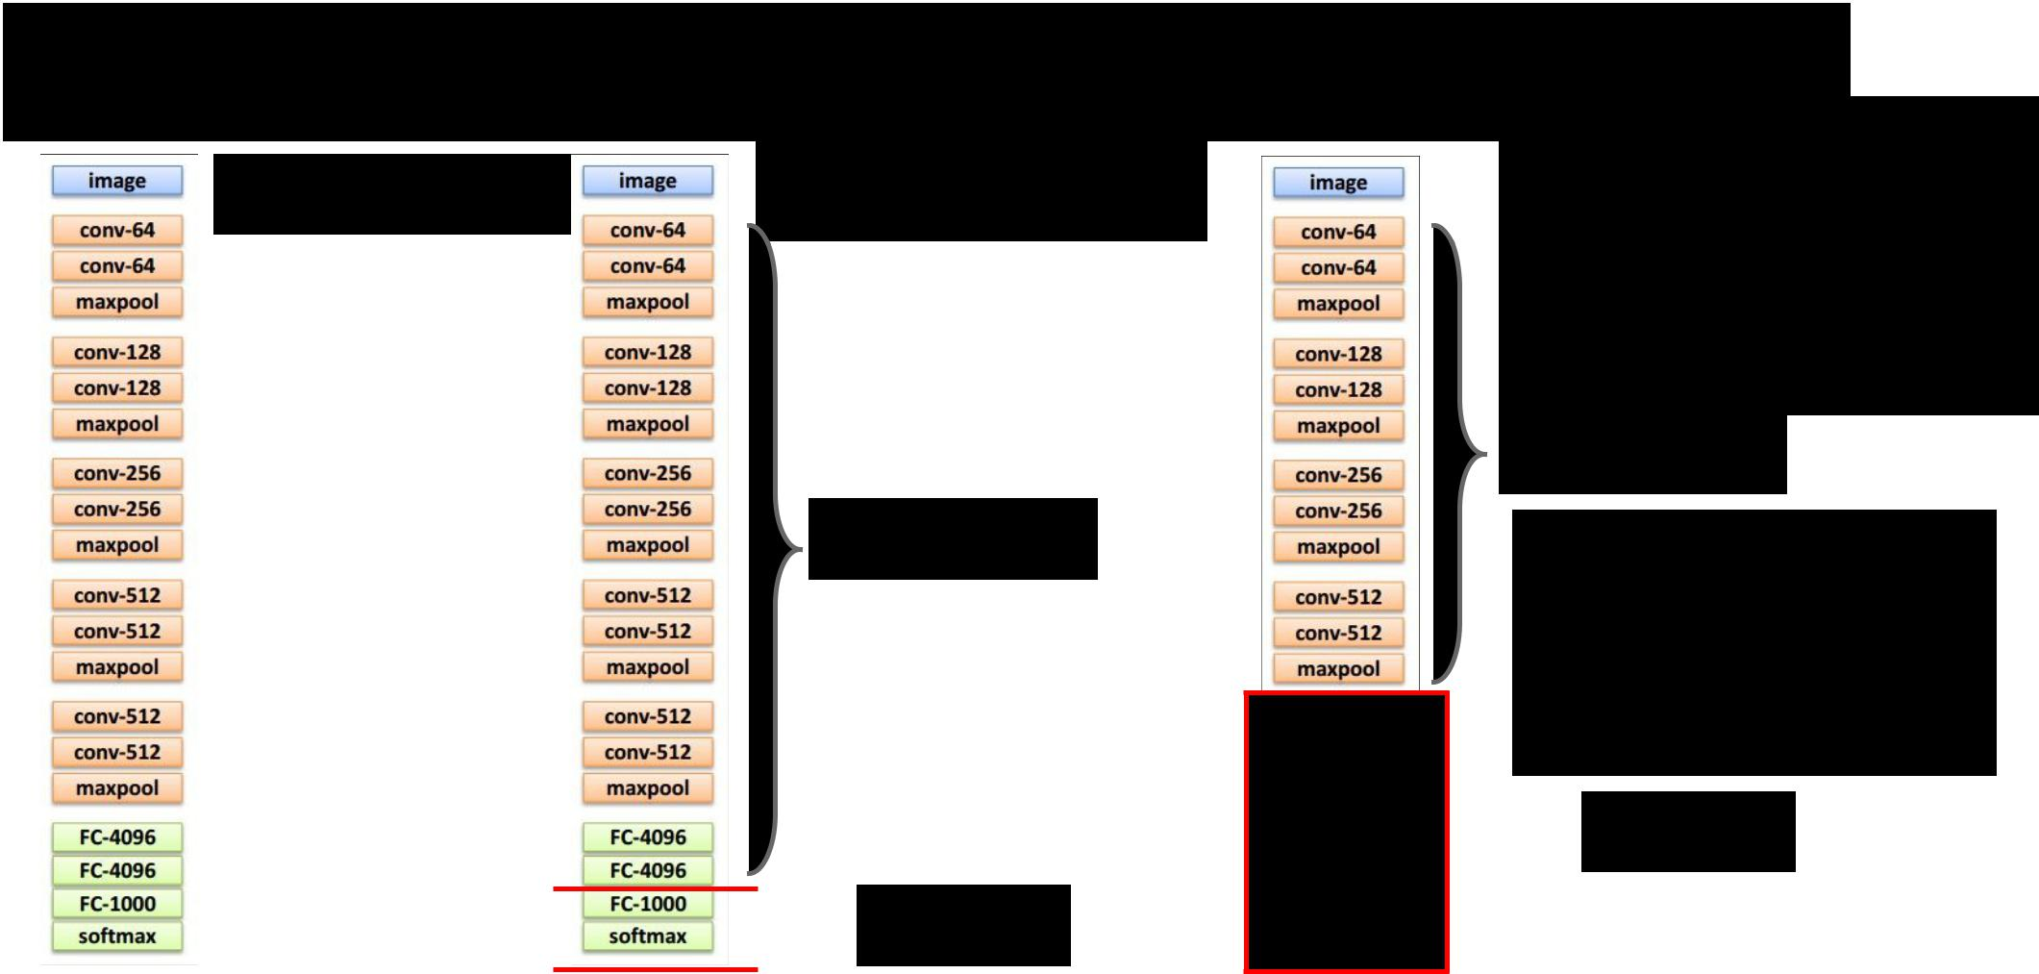Transfer Learning with CNNs

|  |  |
| --- | --- |
|  | 2. Small dataset: |
| 1. Train on | **feature extractor** |
| Imagenet |  |

Freeze these

 Train this



1. Medium dataset: **finetuning**

more data = retrain more of the network (or all of it)

Freeze these

tip: use only ~1/10th of the original learning rate in finetuning top layer, and ~1/100th on intermediate layers

 Train this



Fei-Fei Li & Andrej Karpathy & Justin Johnson Lecture 11 30 17 Feb 2016

*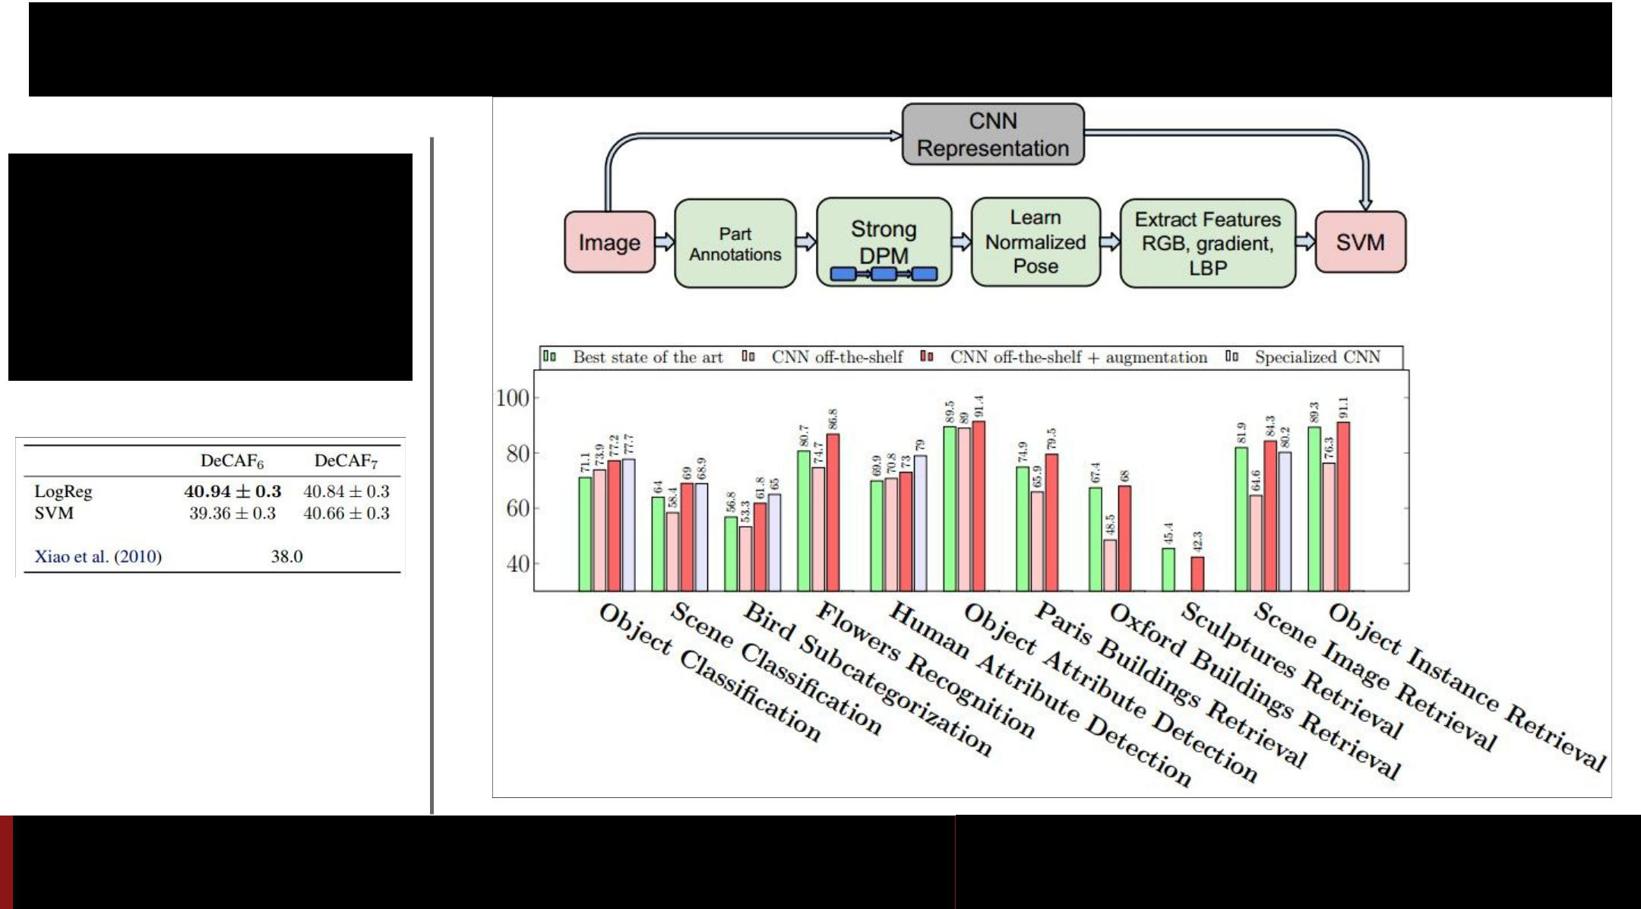CNN Features off-the-shelf: an Astounding Baseline for Recognition [Razavian et al, 2014]*



*DeCAF: A Deep*

*Convolutional Activation*

*Feature for Generic Visual*

*Recognition*

*[Donahue*, Jia*, et al.,*

*2013]*

Fei-Fei Li & Andrej Karpathy & Justin Johnson Lecture 11 31 17 Feb 2016

|  |  |  |  |  |
| --- | --- | --- | --- | --- |
|  |  | **very similar** | **very different** |  |
| more generic |  | **dataset** | **dataset** |  |
|  |  |  |  |
|  |  |  |  |  |
|  | **very little data** | ? | ? |  |
| more specific |  |  |  |  |
|  |  |  |  |  |
|  | **quite a lot of** | ? | ? |  |
|  | **data** |  |  |  |
|  |  |  |  |  |

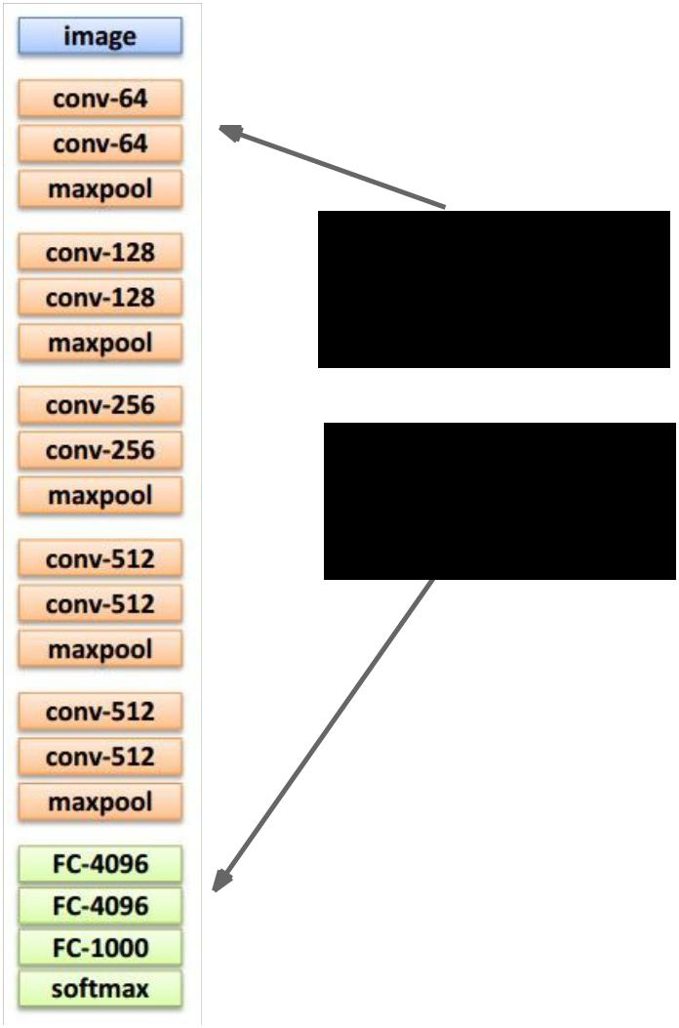

Fei-Fei Li & Andrej Karpathy & Justin Johnson Lecture 11 32 17 Feb 2016

|  |  |  |  |  |
| --- | --- | --- | --- | --- |
|  |  | **very similar** | **very different** |  |
| more generic |  | **dataset** | **dataset** |  |
|  |  |  |  |
|  |  |  |  |  |
|  | **very little data** | Use Linear | ? |  |
| more specific |  | Classifier on top |  |  |
|  | layer |  |  |
|  |  |  |  |
|  |  |  |  |  |
|  | **quite a lot of** | Finetune a few | ? |  |
|  | **data** | layers |  |  |
|  |  |  |  |  |



Fei-Fei Li & Andrej Karpathy & Justin Johnson Lecture 11 33 17 Feb 2016



more generic

more specific

|  |  |  |
| --- | --- | --- |
|  | **very similar** | **very different** |
|  | **dataset** | **dataset** |
|  |  |  |
| **very little data** | Use Linear | You’re in |
|  | Classifier on top | trouble… Try |
|  | layer | linear classifier |
|  |  | from different |
|  |  | stages |
|  |  |  |
| **quite a lot of** | Finetune a few | Finetune a |
| **data** | layers | larger number of |
|  |  | layers |
|  |  |  |



Fei-Fei Li & Andrej Karpathy & Justin Johnson Lecture 11 34 17 Feb 2016

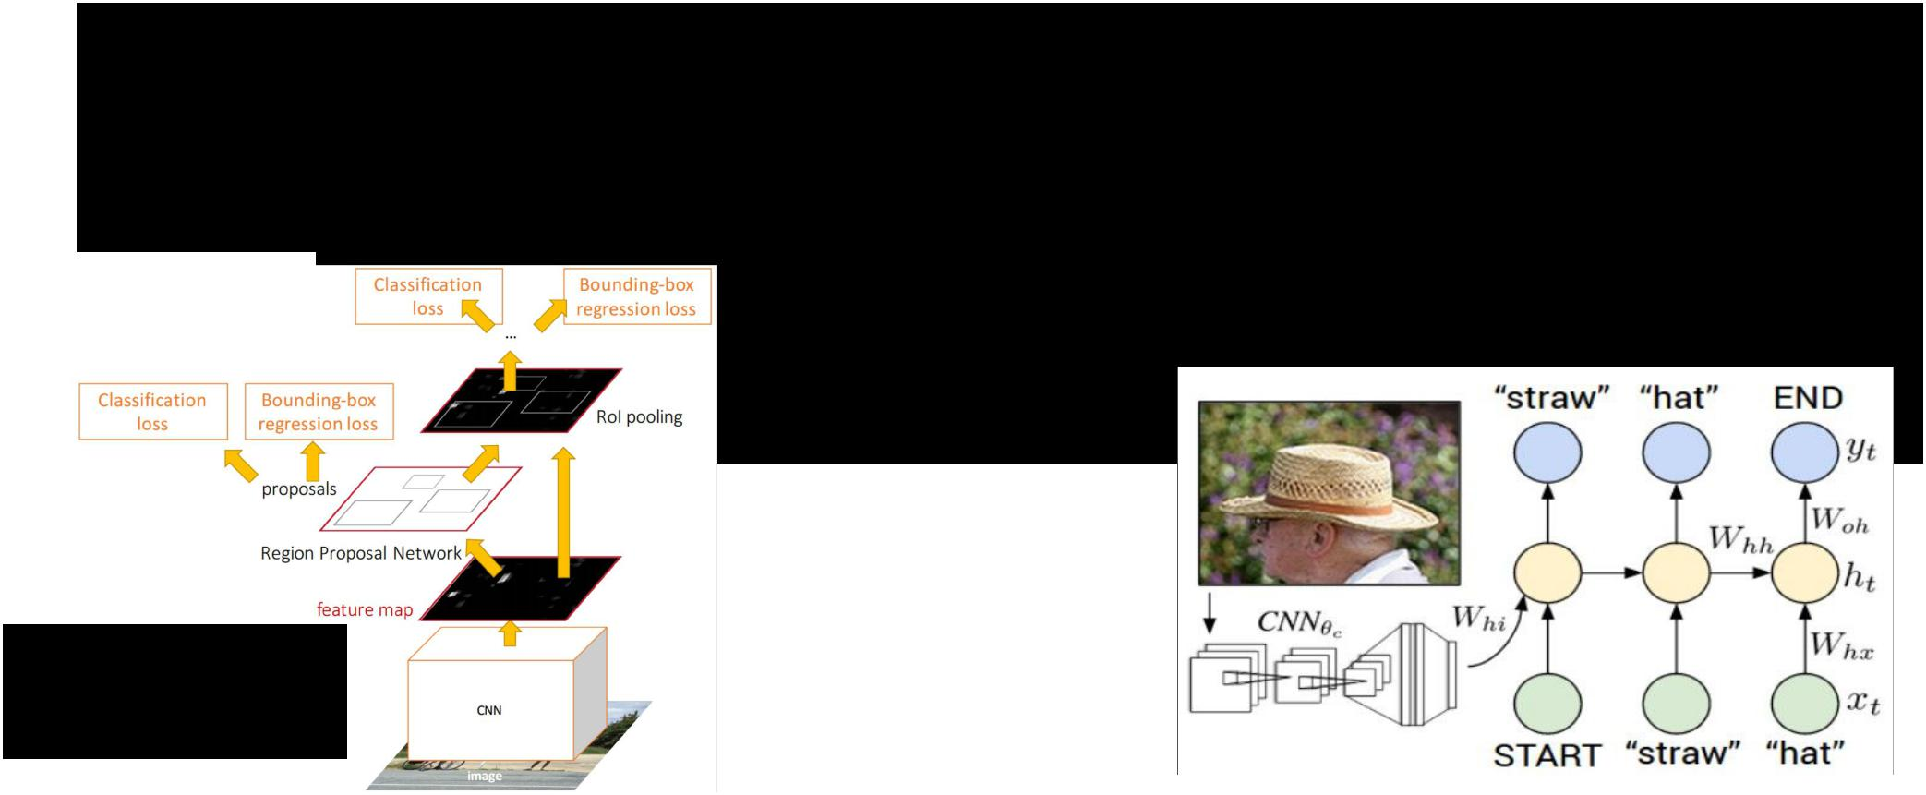Transfer learning with CNNs is pervasive…

(it’s the norm, not an exception)

Image Captioning: CNN + RNN

Object Detection

(Faster R-CNN)



Fei-Fei Li & Andrej Karpathy & Justin Johnson Lecture 11 35 17 Feb 2016

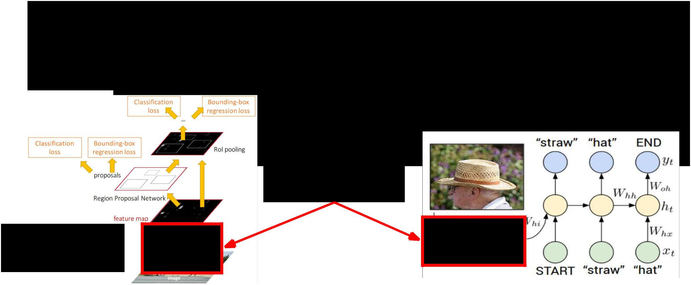Transfer learning with CNNs is pervasive…

(it’s the norm, not an exception)

Image Captioning: CNN + RNN

CNN pretrained on ImageNet

Object Detection

(Faster R-CNN)



Fei-Fei Li & Andrej Karpathy & Justin Johnson Lecture 11 36 17 Feb 2016

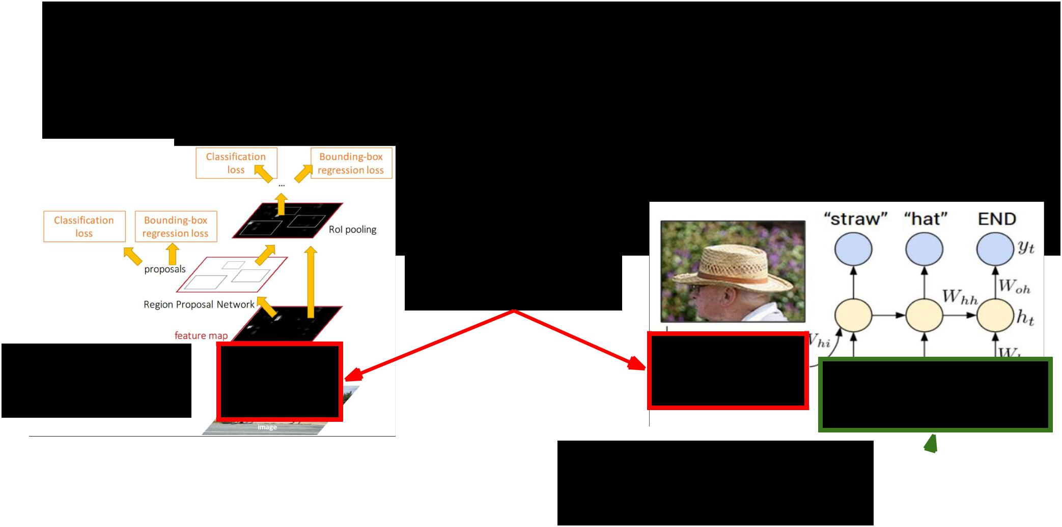

Transfer learning with CNNs is pervasive…

(it’s the norm, not an exception)

Image Captioning: CNN + RNN

CNN pretrained on ImageNet

Object Detection

(Faster R-CNN)

Word vectors pretrained  from word2vec



|  |  |  |
| --- | --- | --- |
| Fei-Fei Li & Andrej Karpathy & Justin Johnson | Lecture 11 37 | 17 Feb 2016 |
|  |  |  |

**Takeaway for your projects/beyond:**

Have some dataset of interest but it has < ~1M images?

1. Find a very large dataset that has similar data, train a big ConvNet there.
2. Transfer learn to your dataset

Caffe ConvNet library has a **“Model Zoo”** of pretrained models:

<https://github.com/BVLC/caffe/wiki/Model-Zoo>



Fei-Fei Li & Andrej Karpathy & Justin Johnson Lecture 11 38 17 Feb 2016



All About Convolutions



Fei-Fei Li & Andrej Karpathy & Justin Johnson Lecture 11 39 17 Feb 2016



All About Convolutions

Part I: How to stack them



Fei-Fei Li & Andrej Karpathy & Justin Johnson Lecture 11 40 17 Feb 2016



**The power of small filters**



Suppose we stack two 3x3 conv layers (stride 1)

Each neuron sees 3x3 region of previous activation map

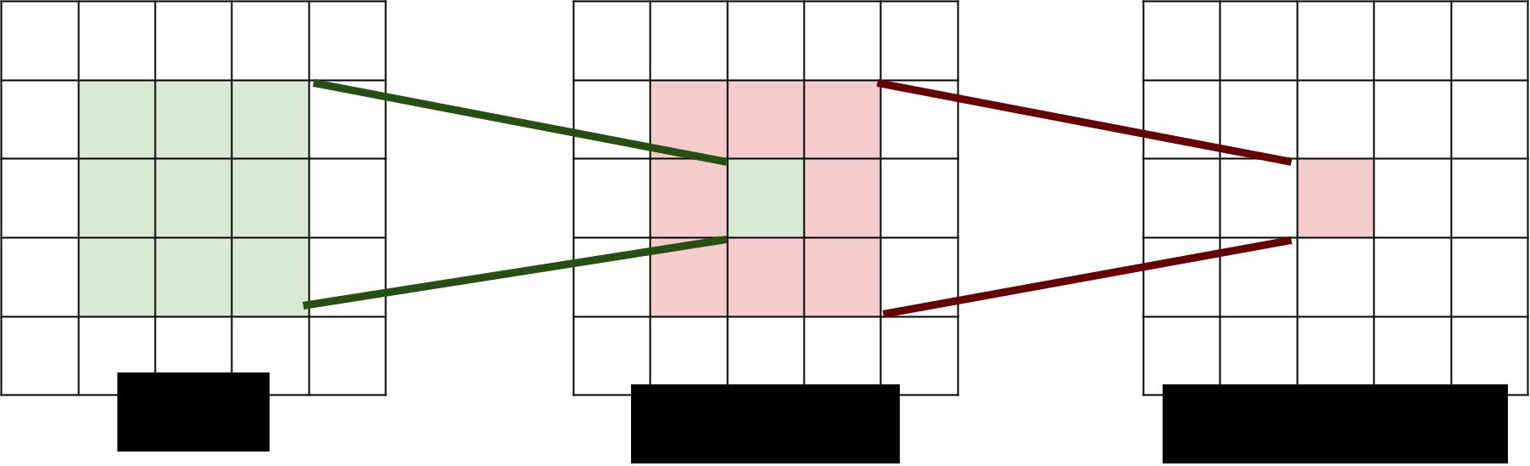

|  |  |  |  |
| --- | --- | --- | --- |
| Input | First Conv | Second Conv | |
|  | |  |  |
| Fei-Fei Li & Andrej Karpathy & Justin Johnson | | Lecture 11 41 | 17 Feb 2016 |
|  |  |  |  |





**The power of small filters**



**Question**: How big of a region in the input does a neuron on thesecond conv layer see?



|  |  |  |  |
| --- | --- | --- | --- |
| Input | First Conv | Second Conv | |
|  | |  |  |
| Fei-Fei Li & Andrej Karpathy & Justin Johnson | | Lecture 11 42 | 17 Feb 2016 |
|  |  |  |  |





**The power of small filters**



**Question**: How big of a region in the input does a neuron on thesecond conv layer see?

**Answer**: 5 x 5



|  |  |  |  |
| --- | --- | --- | --- |
| Input | First Conv | Second Conv | |
|  | |  |  |
| Fei-Fei Li & Andrej Karpathy & Justin Johnson | | Lecture 11 43 | 17 Feb 2016 |
|  |  |  |  |



**The power of small filters**

**Question**: If we stack **three** 3x3 conv layers, how big of an inputregion does a neuron in the third layer see?



Fei-Fei Li & Andrej Karpathy & Justin Johnson Lecture 11 44 17 Feb 2016

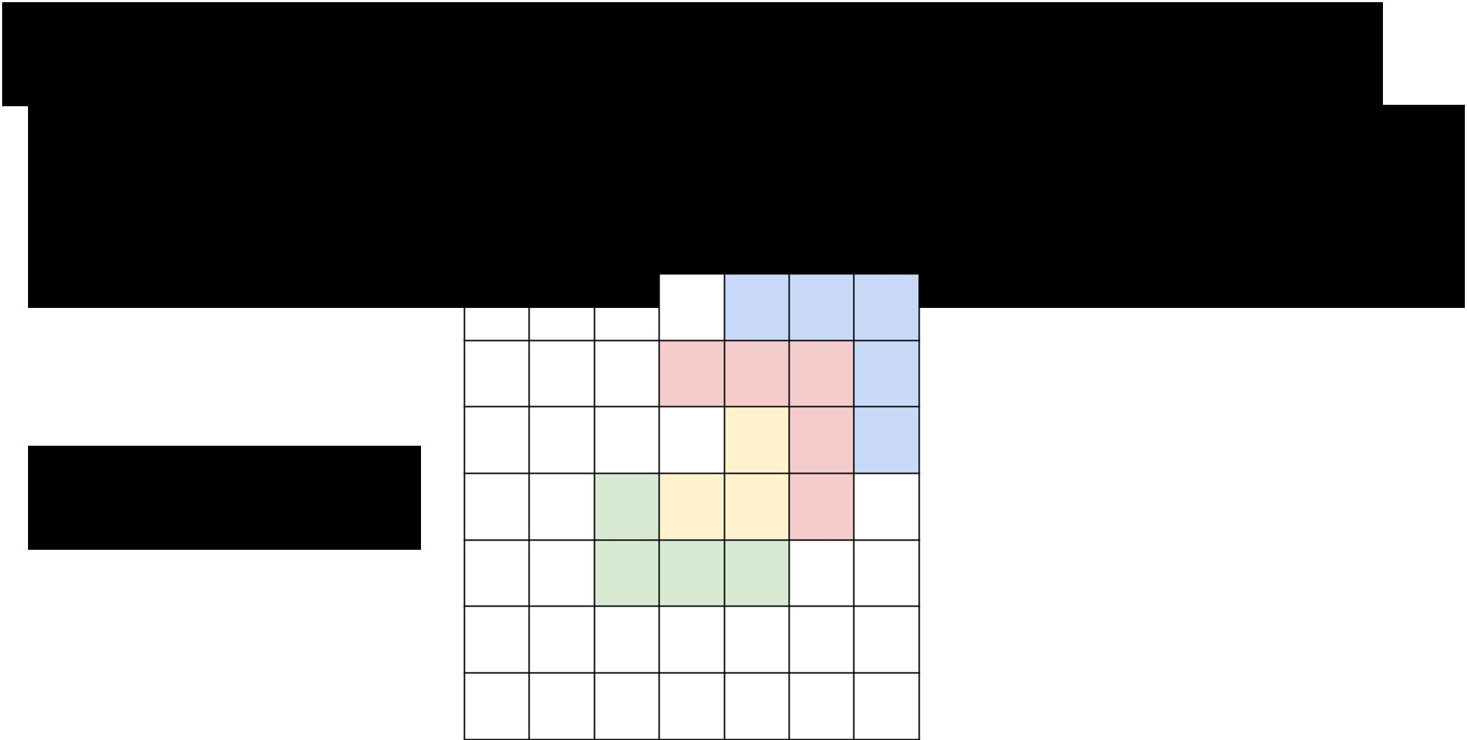**The power of small filters**

**Question**: If we stack **three** 3x3 conv layers, how big of an inputregion does a neuron in the third layer see?

**Answer: 7 x 7**

X

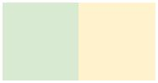 X



Fei-Fei Li & Andrej Karpathy & Justin Johnson Lecture 11 45 17 Feb 2016

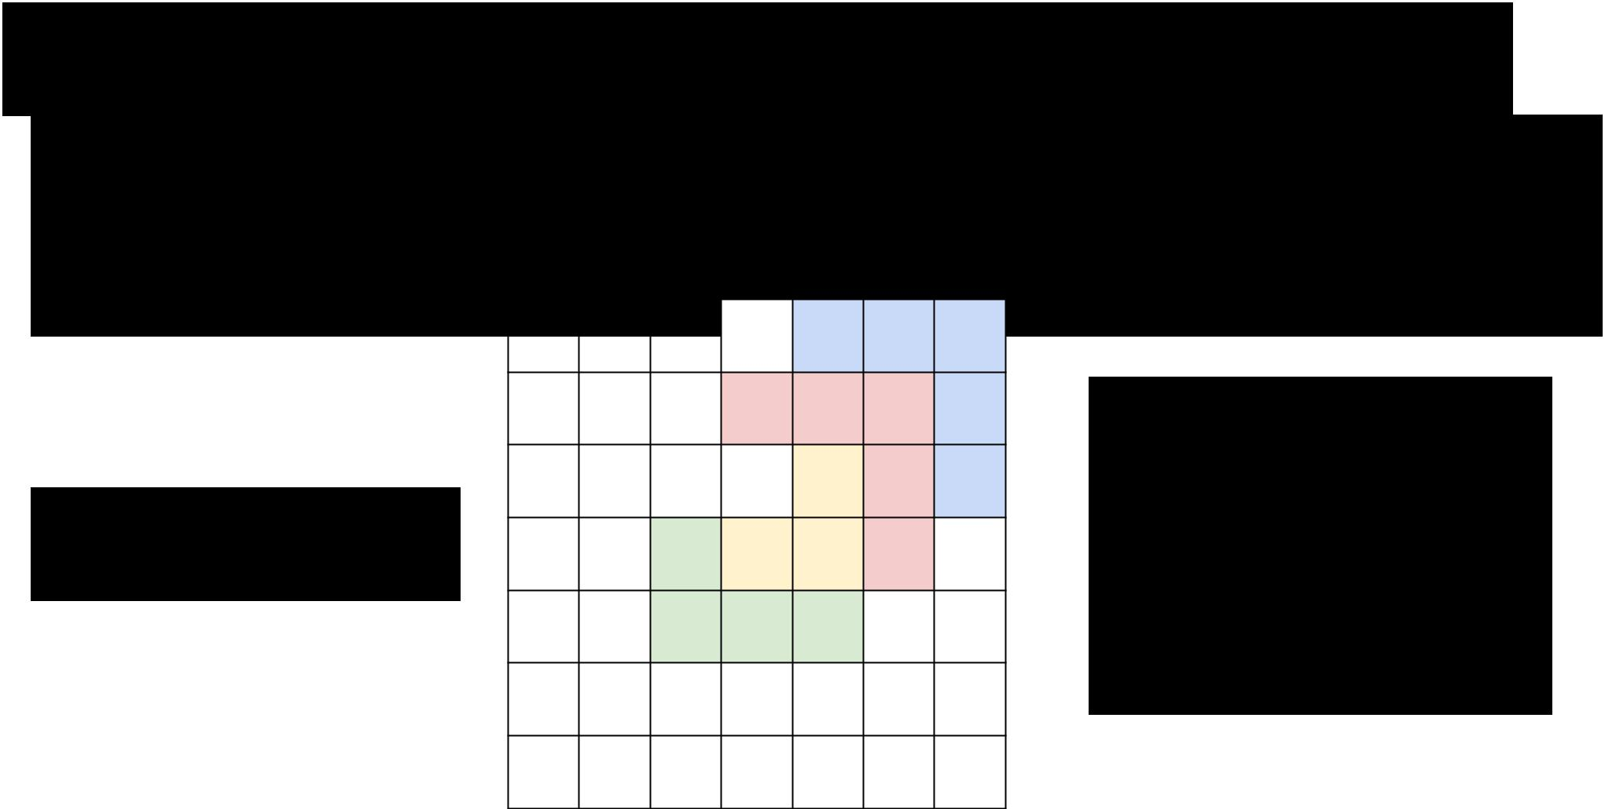**The power of small filters**

**Question**: If we stack **three** 3x3 conv layers, how big of an inputregion does a neuron in the third layer see?

**Answer: 7 x 7**

X

 X



Three 3 x 3 conv

gives similar

representational

power as a single

7 x 7 convolution

Fei-Fei Li & Andrej Karpathy & Justin Johnson Lecture 11 46 17 Feb 2016

**The power of small filters**

Suppose input is H x W x C and we use convolutions with C filters to preserve depth (stride 1, padding to preserve H, W)



Fei-Fei Li & Andrej Karpathy & Justin Johnson Lecture 11 47 17 Feb 2016

**The power of small filters**

Suppose input is H x W x C and we use convolutions with C filters to preserve depth (stride 1, padding to preserve H, W)

one CONV with 7 x 7 filters three CONV with 3 x 3 filters

Number of weights: Number of weights:



Fei-Fei Li & Andrej Karpathy & Justin Johnson Lecture 11 48 17 Feb 2016

**The power of small filters**

Suppose input is H x W x C and we use convolutions with C filters to preserve depth (stride 1, padding to preserve H, W)

one CONV with 7 x 7 filters three CONV with 3 x 3 filters

Number of weights: Number of weights:

= C x (7 x 7 x C) = **49 C2** = 3 x C x (3 x 3 x C) = **27 C2**



Fei-Fei Li & Andrej Karpathy & Justin Johnson Lecture 11 49 17 Feb 2016

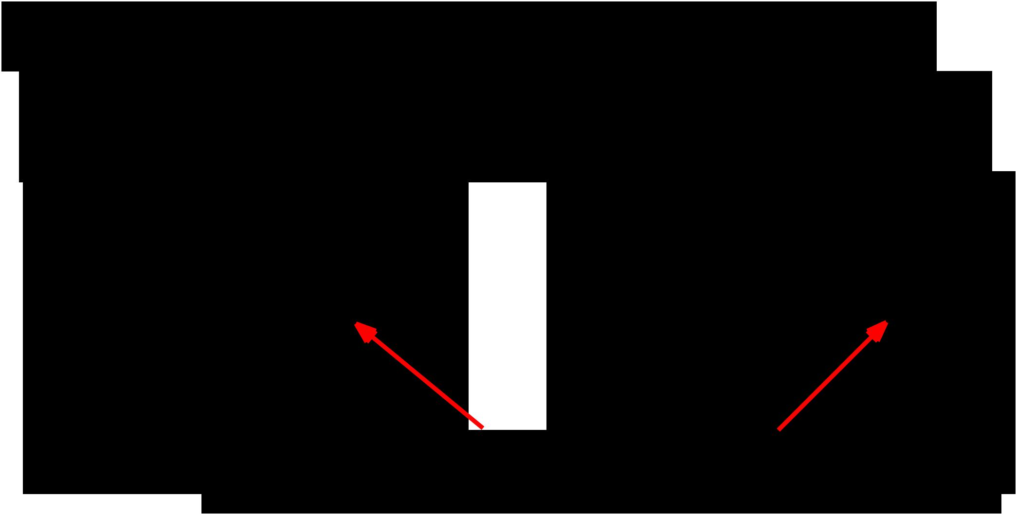**The power of small filters**

Suppose input is H x W x C and we use convolutions with C filters to preserve depth (stride 1, padding to preserve H, W)

one CONV with 7 x 7 filters three CONV with 3 x 3 filters

Number of weights: Number of weights:

= C x (7 x 7 x C) = **49 C2** = 3 x C x (3 x 3 x C) = **27 C2**

Fewer parameters, more nonlinearity = GOOD



Fei-Fei Li & Andrej Karpathy & Justin Johnson Lecture 11 50 17 Feb 2016

**The power of small filters**

Suppose input is H x W x C and we use convolutions with C filters to preserve depth (stride 1, padding to preserve H, W)

one CONV with 7 x 7 filters three CONV with 3 x 3 filters

Number of weights: Number of weights:

= C x (7 x 7 x C) = 49 C2 = 3 x C x (3 x 3 x C) = 27 C2

Number of multiply-adds: Number of multiply-adds:



Fei-Fei Li & Andrej Karpathy & Justin Johnson Lecture 11 51 17 Feb 2016

**The power of small filters**

Suppose input is H x W x C and we use convolutions with C filters to preserve depth (stride 1, padding to preserve H, W)

one CONV with 7 x 7 filters

Number of weights:

= C x (7 x 7 x C) = 49 C2

Number of multiply-adds:

* (H x W x C) x (7 x 7 x C)
* **49 HWC2**

three CONV with 3 x 3 filters

Number of weights:

= 3 x C x (3 x 3 x C) = 27 C2

Number of multiply-adds:

* 3 x (H x W x C) x (3 x 3 x C)
* **27 HWC2**



Fei-Fei Li & Andrej Karpathy & Justin Johnson Lecture 11 52 17 Feb 2016

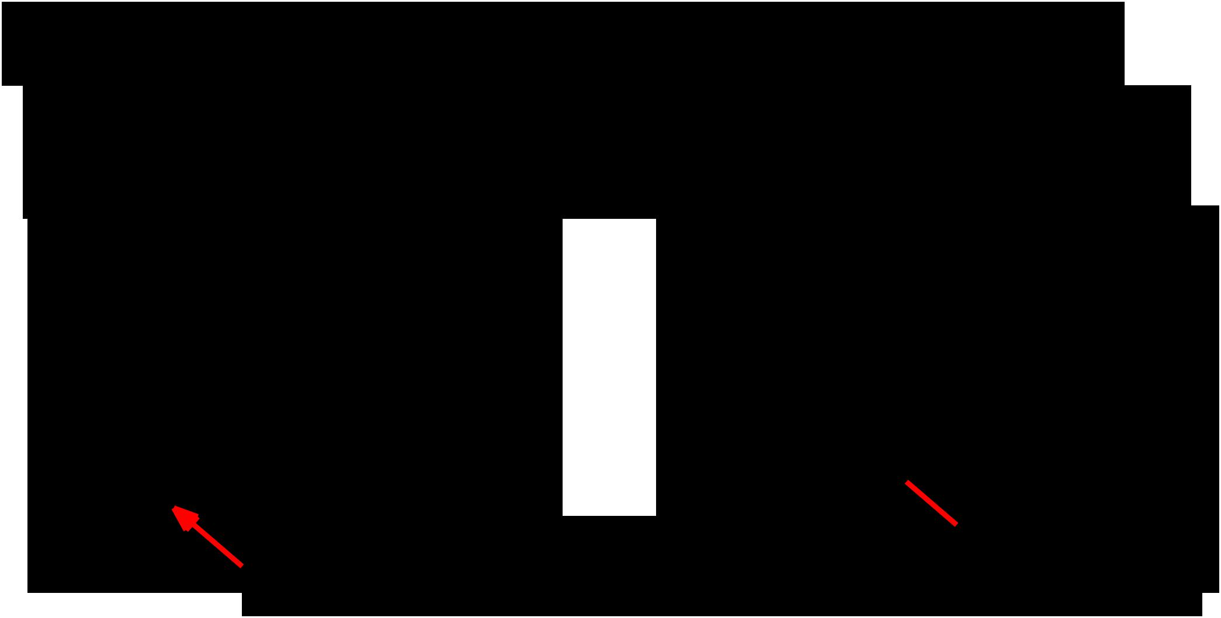**The power of small filters**

Suppose input is H x W x C and we use convolutions with C filters to preserve depth (stride 1, padding to preserve H, W)

one CONV with 7 x 7 filters three CONV with 3 x 3 filters

Number of weights: Number of weights:

= C x (7 x 7 x C) = 49 C2 = 3 x C x (3 x 3 x C) = 27 C2

Number of multiply-adds: Number of multiply-adds:

= **49 HWC2** = **27 HWC2** 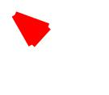

Less compute, more nonlinearity = GOOD



Fei-Fei Li & Andrej Karpathy & Justin Johnson Lecture 11 53 17 Feb 2016

**The power of small filters**



Why stop at 3 x 3 filters? Why not try 1 x 1?



Fei-Fei Li & Andrej Karpathy & Justin Johnson Lecture 11 54 17 Feb 2016

**The power of small filters**



Why stop at 3 x 3 filters? Why not try 1 x 1?

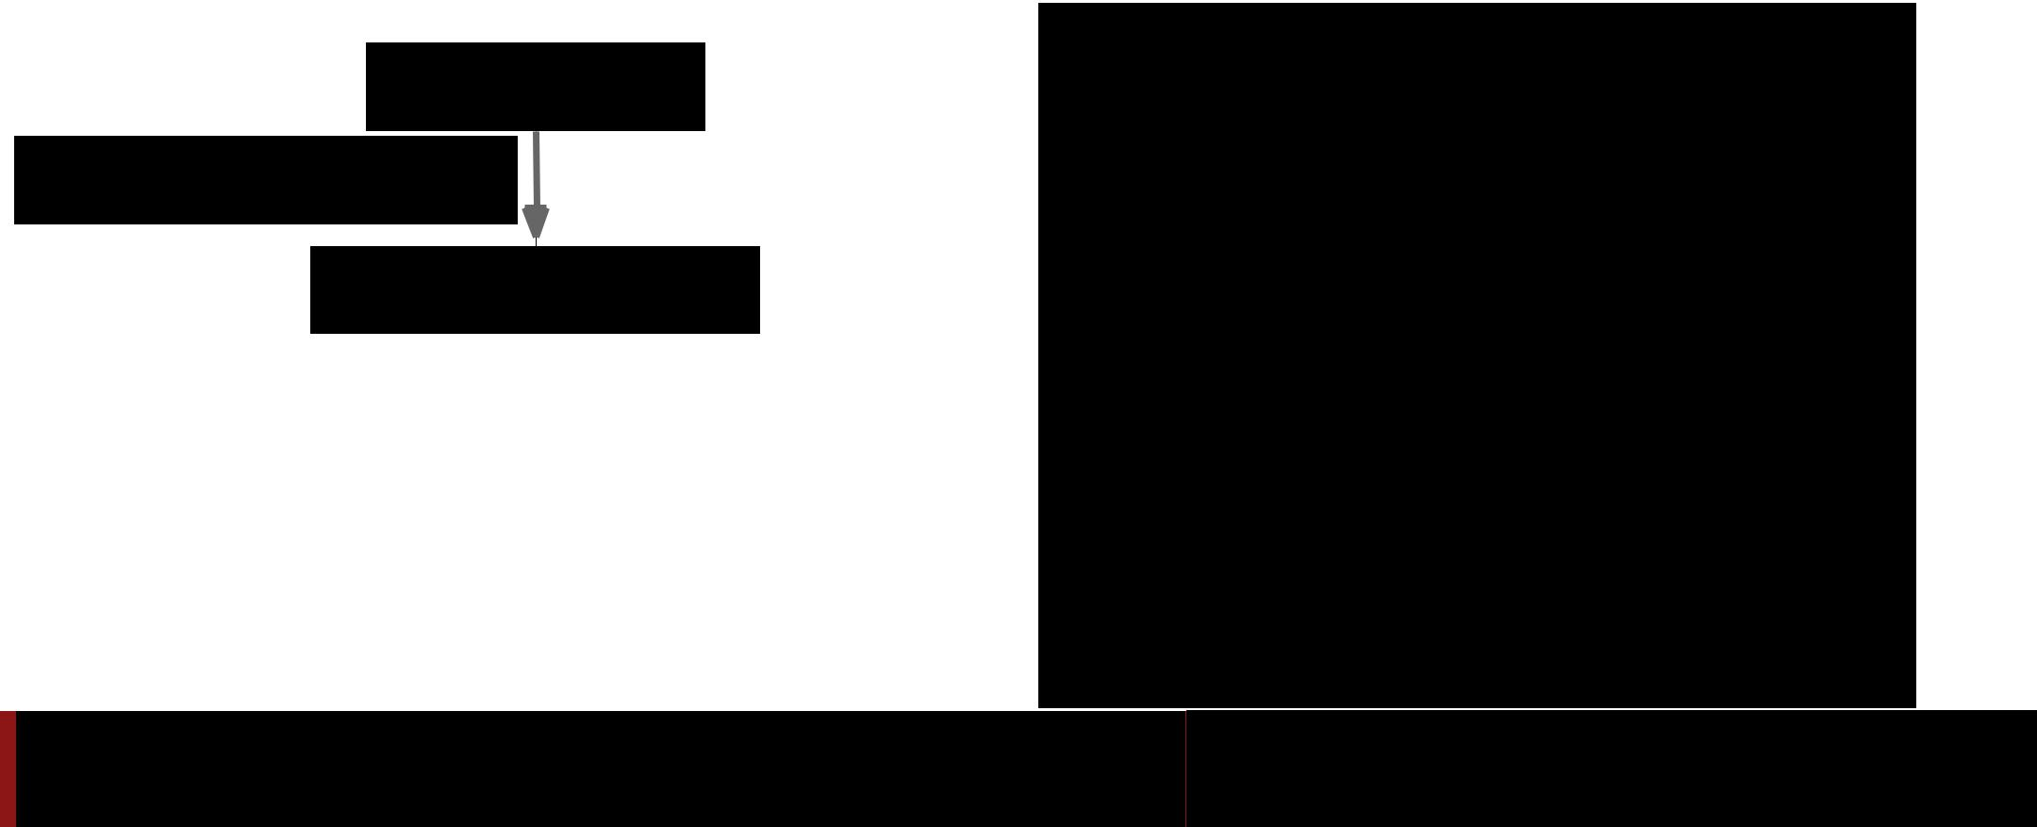

|  |  |  |
| --- | --- | --- |
| H x W x C | 1. “bottleneck” 1 x 1 conv |  |
| to reduce dimension |  |
|  |  |

Conv 1x1, C/2 filters

H x W x (C / 2)

Fei-Fei Li & Andrej Karpathy & Justin Johnson Lecture 11 55 17 Feb 2016

**The power of small filters**



Why stop at 3 x 3 filters? Why not try 1 x 1?

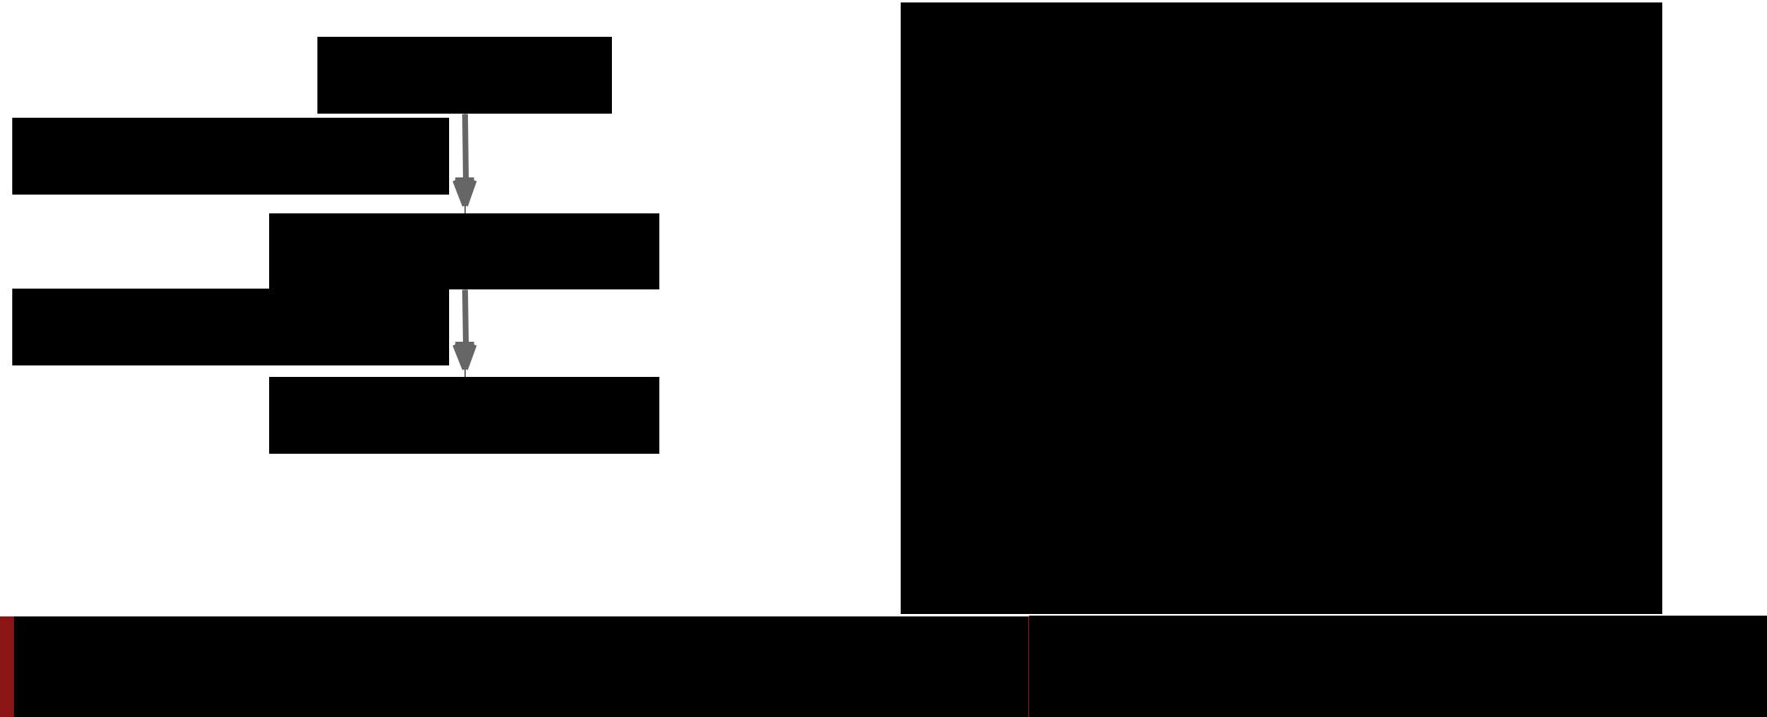

H x W x C

Conv 1x1, C/2 filters

H x W x (C / 2)

Conv 3x3, C/2 filters

1. “bottleneck” 1 x 1 conv to reduce dimension
2. 3 x 3 conv at reduced dimension

H x W x (C / 2)

Fei-Fei Li & Andrej Karpathy & Justin Johnson Lecture 11 56 17 Feb 2016

**The power of small filters**



Why stop at 3 x 3 filters? Why not try 1 x 1?

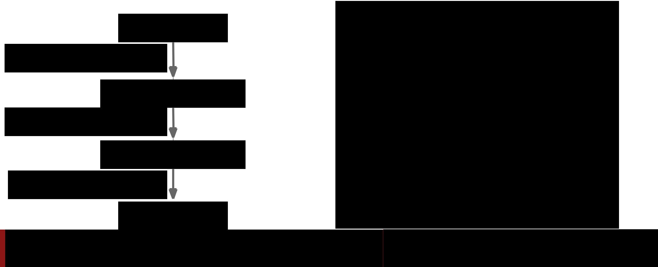

H x W x C

Conv 1x1, C/2 filters

H x W x (C / 2)

Conv 3x3, C/2 filters

H x W x (C / 2)



Conv 1x1, C filters

H x W x C

1. “bottleneck” 1 x 1 conv to reduce dimension
2. 3 x 3 conv at reduced dimension
3. Restore dimension with another 1 x 1 conv

[Seen in Lin et al, “Network in Network”, GoogLeNet, ResNet]

Fei-Fei Li & Andrej Karpathy & Justin Johnson Lecture 11 57 17 Feb 2016

**The power of small filters**



Why stop at 3 x 3 filters? Why not try 1 x 1?

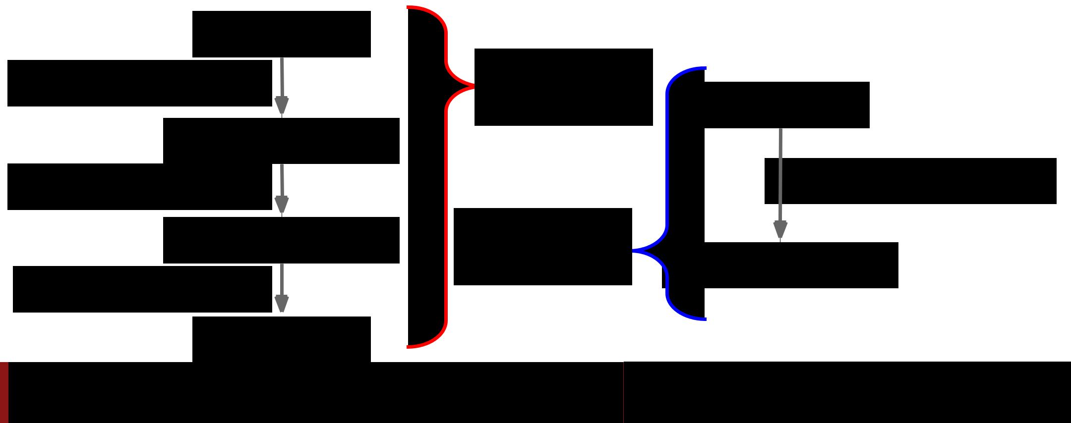

H x W x C

Conv 1x1, C/2 filters

H x W x (C / 2)

Conv 3x3, C/2 filters

H x W x (C / 2)



Conv 1x1, C filters

H x W x C

|  |  |  |
| --- | --- | --- |
| **Bottleneck** | H x W x C |  |
| **sandwich** |  |

Conv 3x3, C filters

|  |  |  |
| --- | --- | --- |
| **Single** | H x W x C |  |
| **3 x 3 conv** |  |

Fei-Fei Li & Andrej Karpathy & Justin Johnson Lecture 11 58 17 Feb 2016

**The power of small filters**

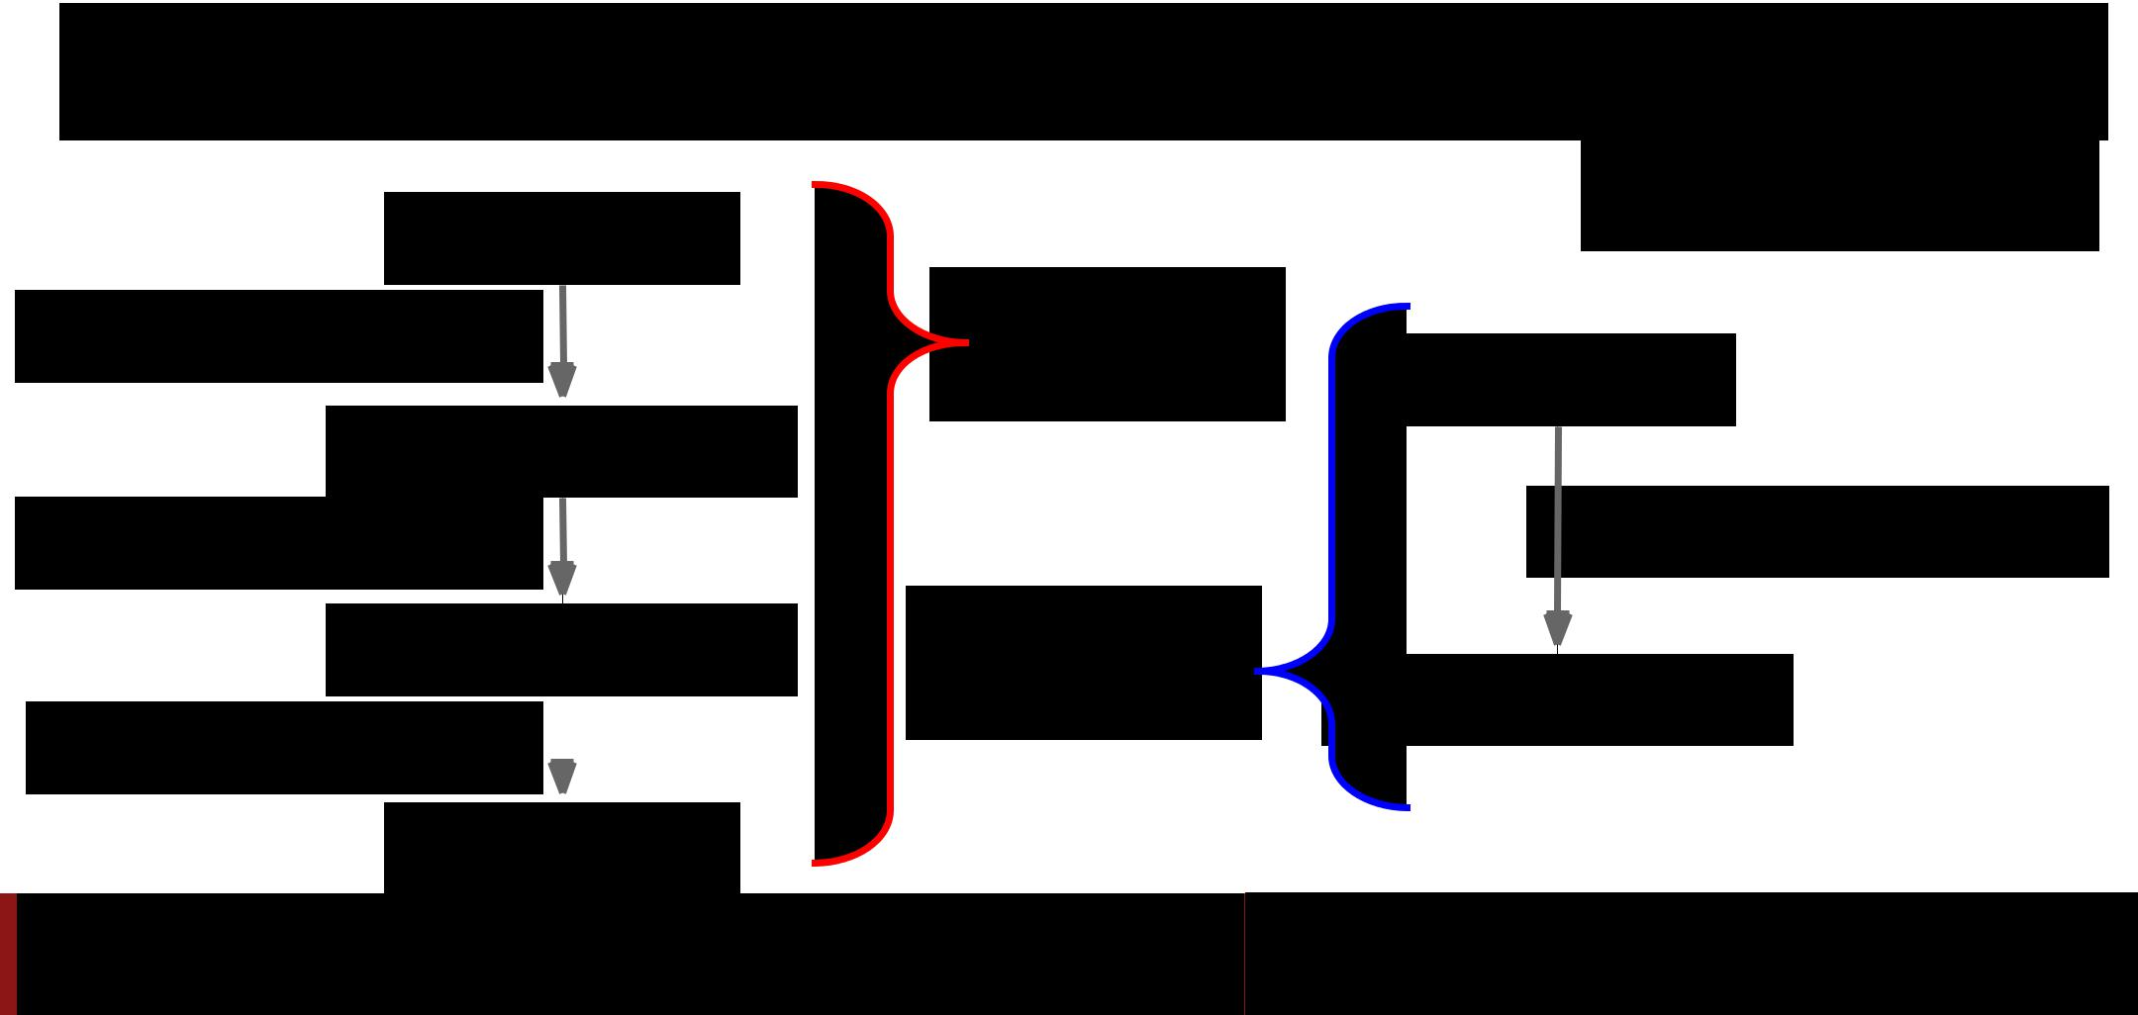

Why stop at 3 x 3 filters? Why not try 1 x 1?

H x W x C

More nonlinearity,

fewer params, less compute!

|  |  |  |  |
| --- | --- | --- | --- |
| Conv 1x1, C/2 filters | **3.25 C2** | H x W x C |  |
| **parameters** |  |
|  |  |

H x W x (C / 2)

|  |  |
| --- | --- |
| Conv 3x3, C/2 filters | Conv 3x3, C filters |

|  |  |  |  |  |  |
| --- | --- | --- | --- | --- | --- |
| H x W x (C / 2) | | | **9 C2** | H x W x C |  |
| Conv 1x1, C filters |  |  | **parameters** |  |
|  |  |  |
|  |  |  |  |  |
|  |  |  |  |



H x W x C

Fei-Fei Li & Andrej Karpathy & Justin Johnson Lecture 11 59 17 Feb 2016

**The power of small filters**



Still using 3 x 3 filters … can we break it up?



Fei-Fei Li & Andrej Karpathy & Justin Johnson Lecture 11 60 17 Feb 2016

**The power of small filters**



Still using 3 x 3 filters … can we break it up?

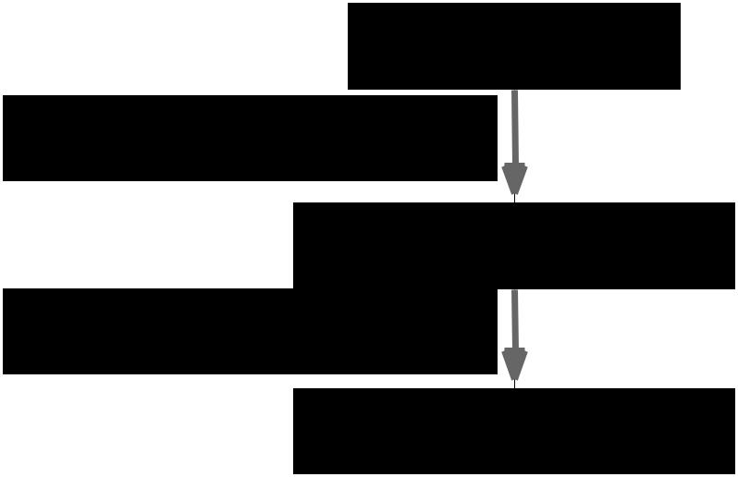

H x W x C

Conv 1x3, C filters

H x W x C

Conv 3x1, C filters

H x W x C



Fei-Fei Li & Andrej Karpathy & Justin Johnson Lecture 11 61 17 Feb 2016

**The power of small filters**



Still using 3 x 3 filters … can we break it up?

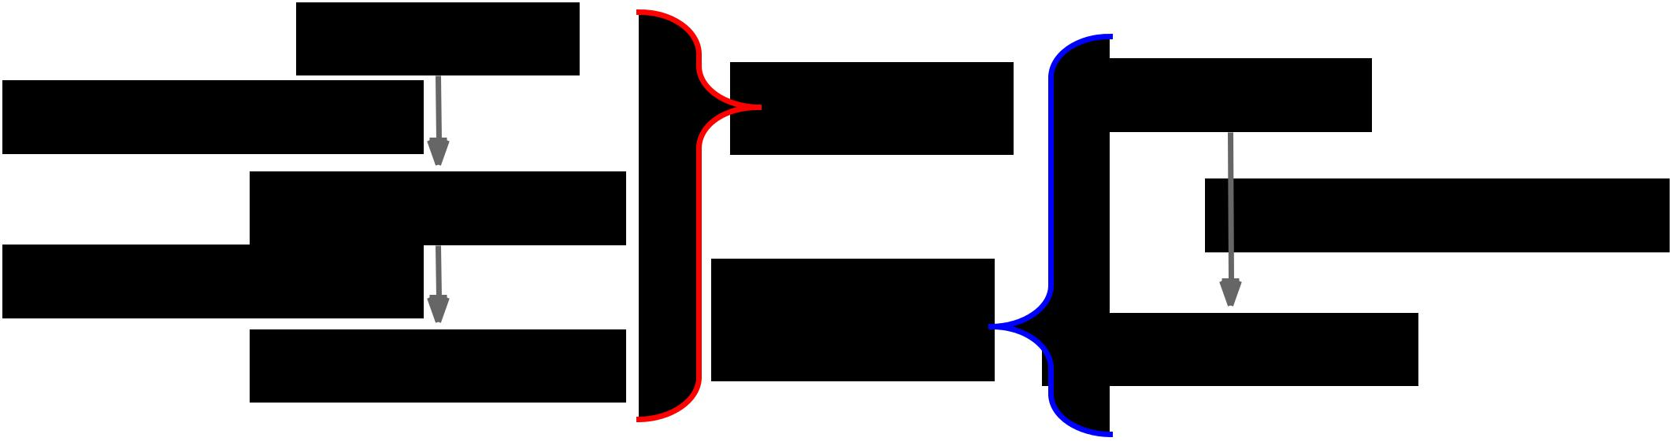

More nonlinearity,

fewer params, less compute!

|  |  |  |  |  |  |
| --- | --- | --- | --- | --- | --- |
| H x W x C | | **6 C2** | H x W x C | |  |
| Conv 1x3, C filters |  |  |
|  | **parameters** |  |  |  |
|  |  |  |  |  |
| H x W x C | |  |  | Conv 3x3, C filters |  |
| Conv 3x1, C filters |  | **9 C2** |  |  |  |
|  | H x W x C | |  |
| H x W x C | | **parameters** |  |



Fei-Fei Li & Andrej Karpathy & Justin Johnson Lecture 11 62 17 Feb 2016

**The power of small filters**

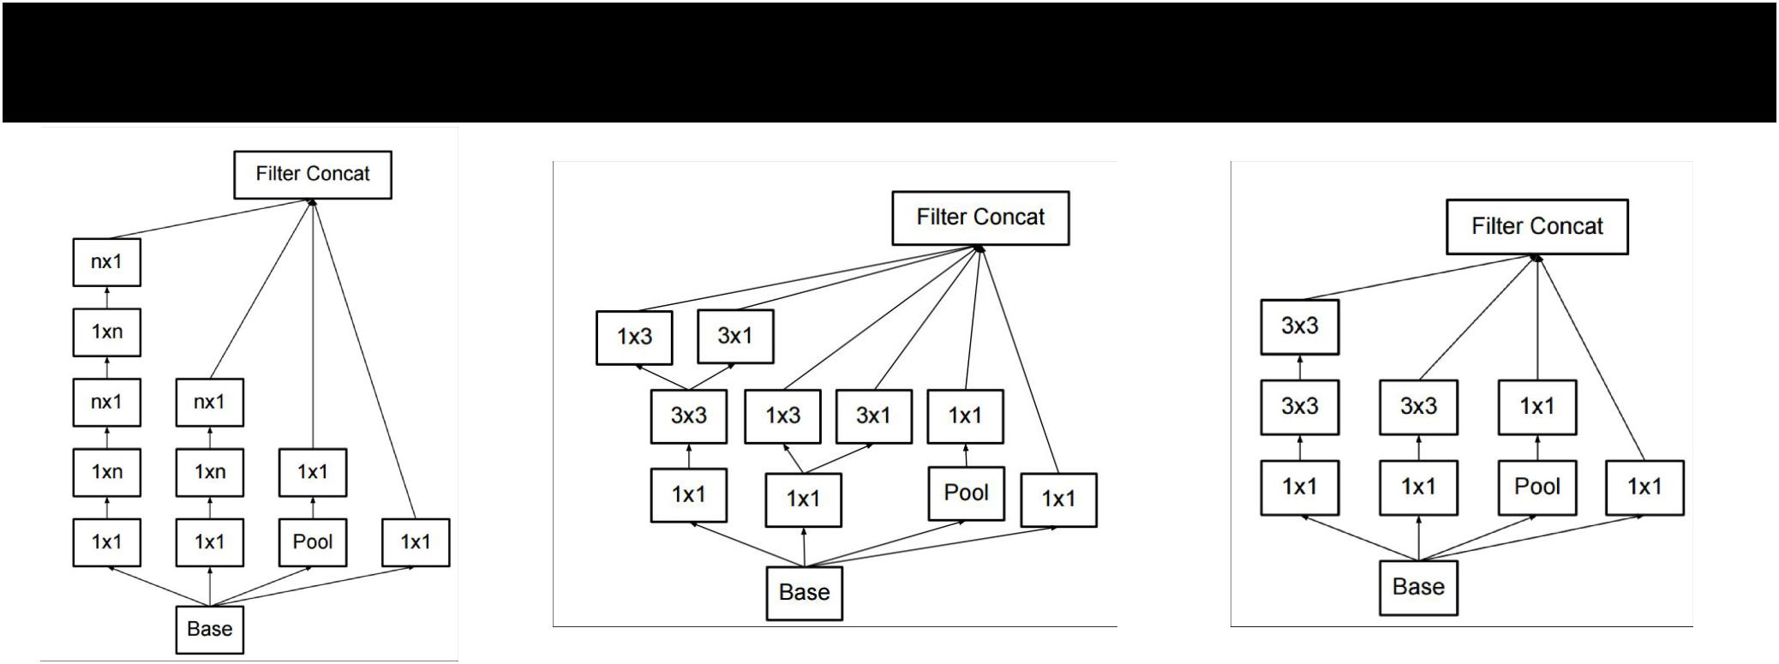

Latest version of GoogLeNet incorporates all these ideas



Szegedy et al, “Rethinking the Inception Architecture for Computer Vision”

Fei-Fei Li & Andrej Karpathy & Justin Johnson Lecture 11 63 17 Feb 2016

How to stack convolutions: Recap



* Replace large convolutions (5 x 5, 7 x 7) with stacks of 3 x 3 convolutions
* 1 x 1 “bottleneck” convolutions are very efficient
* Can factor N x N convolutions into 1 x N and N x 1
* All of the above give fewer parameters, less compute, more nonlinearity



Fei-Fei Li & Andrej Karpathy & Justin Johnson Lecture 11 64 17 Feb 2016



All About Convolutions

Part II: How to compute them



Fei-Fei Li & Andrej Karpathy & Justin Johnson Lecture 11 65 17 Feb 2016

Implementing Convolutions: im2col

There are highly optimized matrix multiplication routines for just about every platform

Can we turn convolution into matrix multiplication?



Fei-Fei Li & Andrej Karpathy & Justin Johnson Lecture 11 66 17 Feb 2016

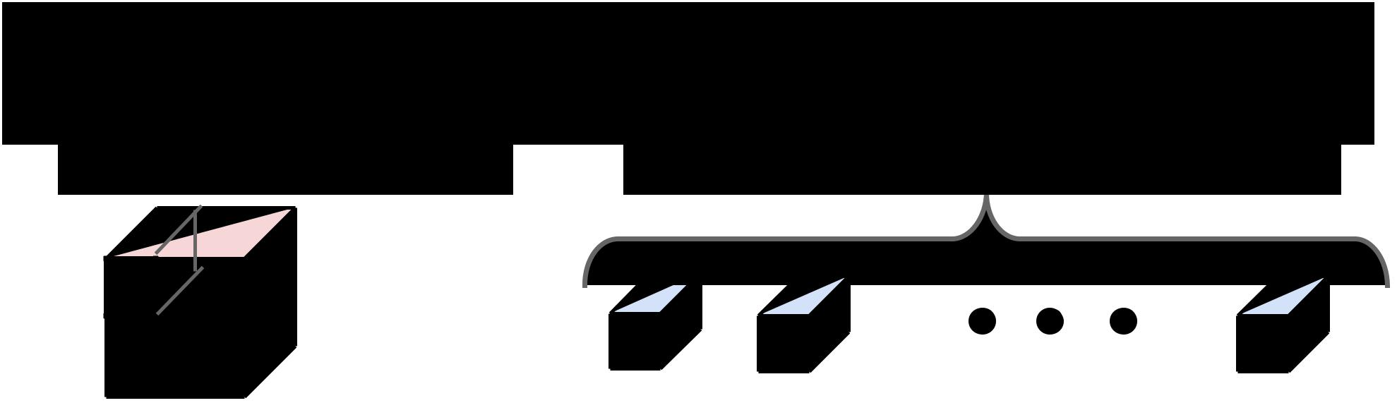Implementing Convolutions: im2col

Feature map: H x W x C Conv weights: D filters, each K x K x C



Fei-Fei Li & Andrej Karpathy & Justin Johnson Lecture 11 - 17 Feb 2016

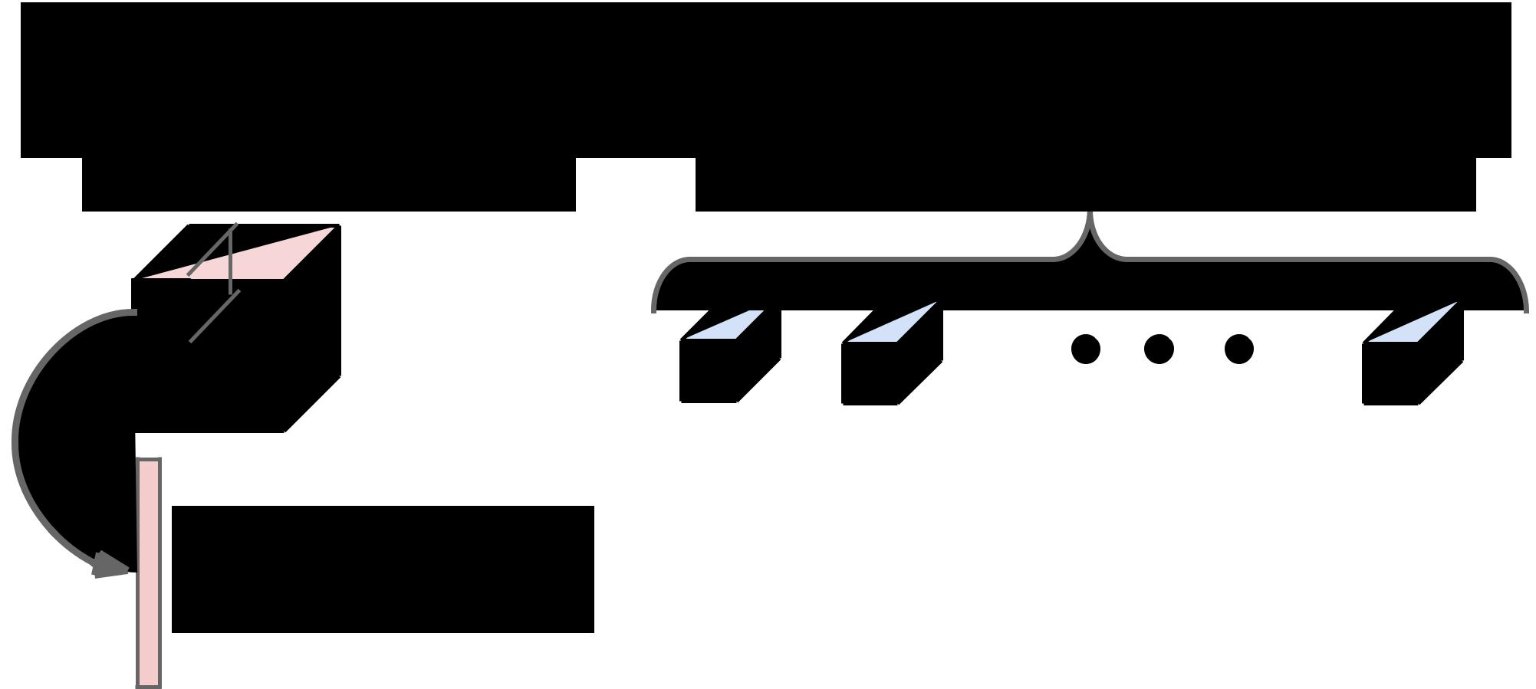Implementing Convolutions: im2col

Feature map: H x W x C Conv weights: D filters, each K x K x C



Reshape K x K x C

receptive field to column

with K2C elements



Fei-Fei Li & Andrej Karpathy & Justin Johnson Lecture 11 - 17 Feb 2016

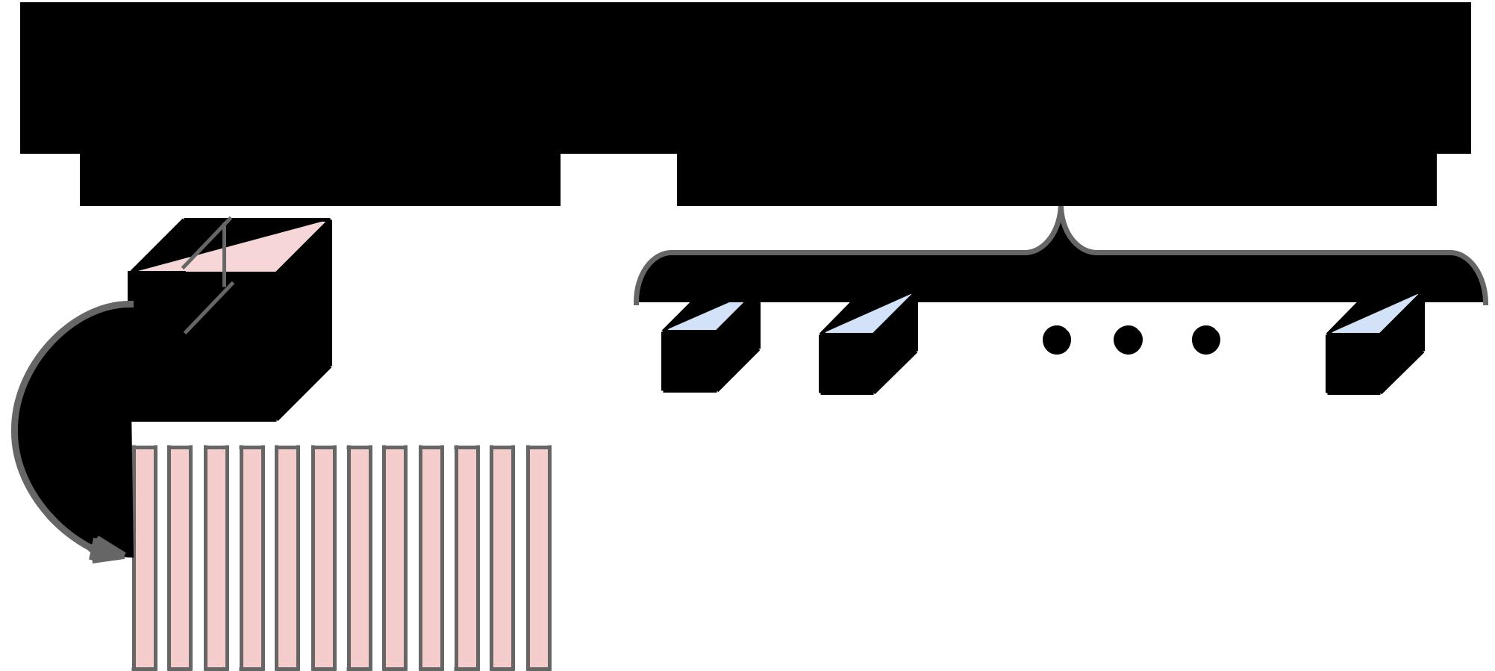Implementing Convolutions: im2col

Feature map: H x W x C Conv weights: D filters, each K x K x C



Repeat for all columns to get (K2C) x N matrix

(N receptive field locations)



Fei-Fei Li & Andrej Karpathy & Justin Johnson Lecture 11 - 17 Feb 2016

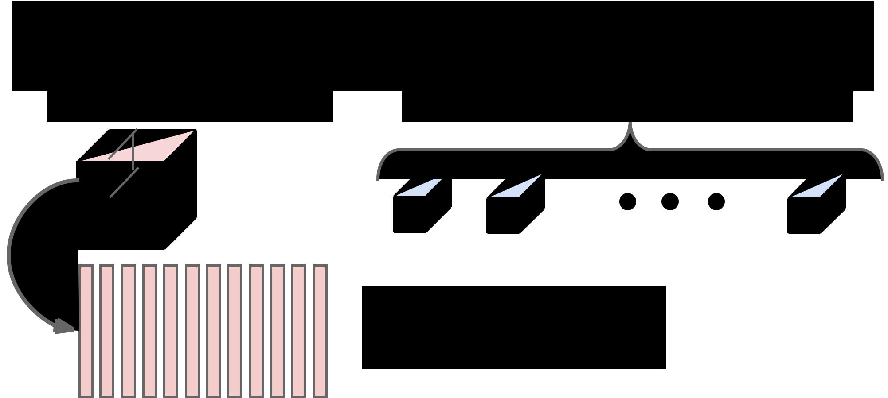Implementing Convolutions: im2col

Feature map: H x W x C Conv weights: D filters, each K x K x C



Elements appearing in multiple

receptive fields are duplicated; this

uses a lot of memory



Repeat for all columns to get (K2C) x N matrix

(N receptive field locations)



Fei-Fei Li & Andrej Karpathy & Justin Johnson Lecture 11 - 17 Feb 2016

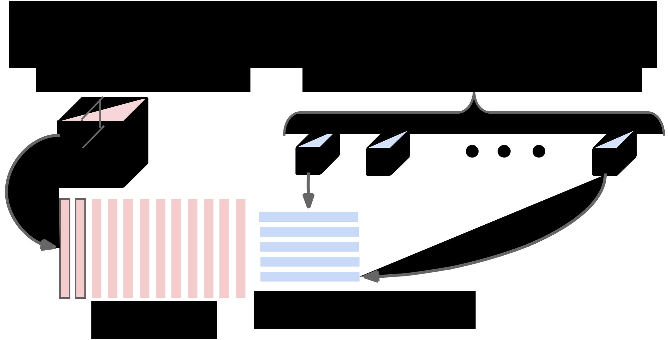Implementing Convolutions: im2col

Feature map: H x W x C Conv weights: D filters, each K x K x C



|  |  |  |  |  |  |  |  |  |  |  |  |  |  |  |  |  |  |  |  |  |  |  |
| --- | --- | --- | --- | --- | --- | --- | --- | --- | --- | --- | --- | --- | --- | --- | --- | --- | --- | --- | --- | --- | --- | --- |
|  |  |  |  |  |  |  |  |  |  |  |  |  |  |  |  |  |  |  |  |  |  |  |
|  |  |  |  |  |  |  |  |  |  |  |  |  |  |  |  |  |  |  |  |  |  |  |
|  |  |  |  |  |  |  |  |  |  |  |  |  |  |  |  |  |  |  |  |  |  |  |
|  |  |  |  |  |  |  |  |  |  |  |  |  |  |  |  |  |  |  |  |  |  |  |
|  |  |  |  |  |  |  |  |  |  |  |  |  |  |  |  |  |  |  |  |  |  |  |
|  |  |  |  |  |  |  |  |  |  |  |  |  |  |  |  |  |  |  |  |  |  |  |
|  |  |  |  |  |  |  |  |  |  |  |  |  |  |  |  |  |  |  |  |  |  |  |
|  |  |  |  |  |  |  |  |  |  |  |  |  |  |  |  |  |  |  |  |  |  |  |
|  |  |  |  |  |  |  |  |  |  |  |  |  |  |  |  |  |  |  |  |  |  |  |
|  |  |  |  |  |  |  |  |  |  |  |  |  |  |  |  |  |  |  |  |  |  |  |
|  |  |  |  |  |  |  |  |  |  |  |  |  |  |  |  |  |  |  |  | Reshape each filter to K2C row, | |  |
| (K2C) x N matrix | | | | | | | | | | | | | |  |  |  |  |  |  |  |
|  |  |  |  |  |  | making D x (K2C) matrix | |  |



Fei-Fei Li & Andrej Karpathy & Justin Johnson Lecture 11 - 17 Feb 2016

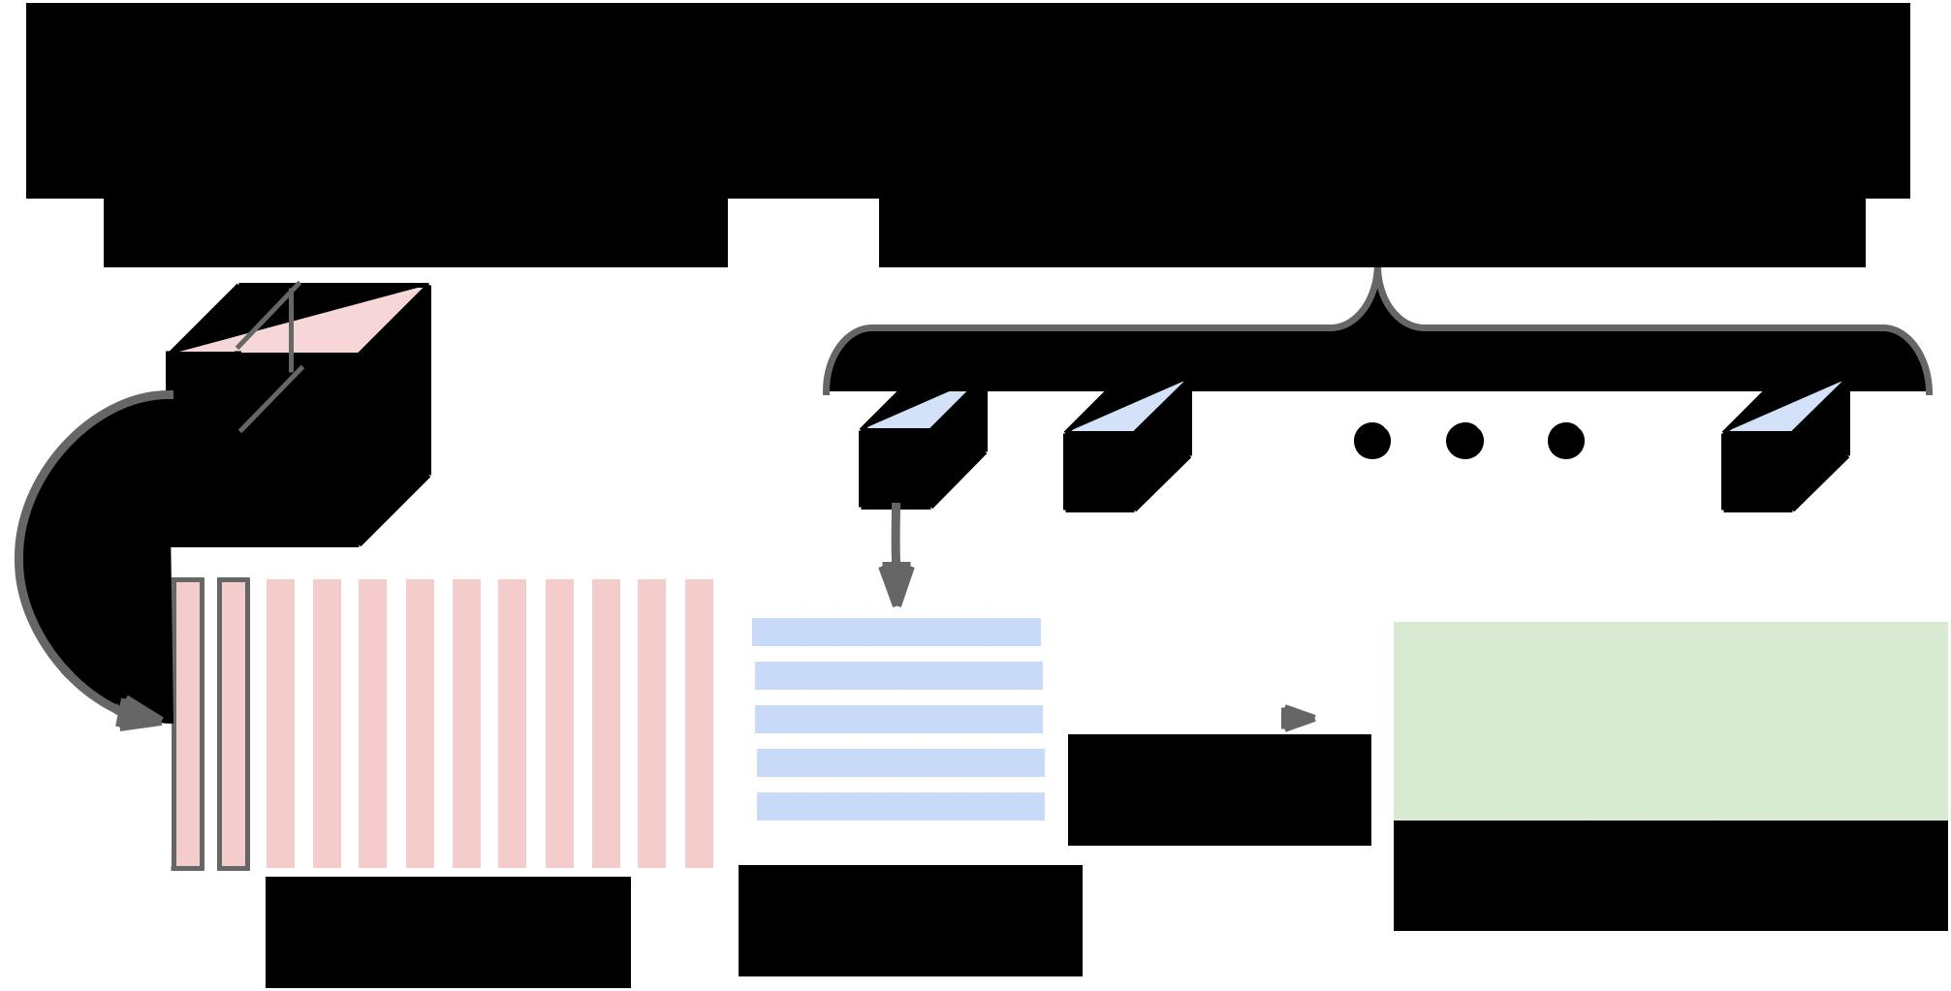Implementing Convolutions: im2col

Feature map: H x W x C Conv weights: D filters, each K x K x C



|  |  |  |  |  |  |  |  |  |  |  |  |  |  |  |  |  |  |  |  |  |  |  |  |  |  |  |
| --- | --- | --- | --- | --- | --- | --- | --- | --- | --- | --- | --- | --- | --- | --- | --- | --- | --- | --- | --- | --- | --- | --- | --- | --- | --- | --- |
|  |  |  |  |  |  |  |  |  |  |  |  |  |  |  |  |  |  |  |  |  |  |  |  |  |  |  |
|  |  |  |  |  |  |  |  |  |  |  |  |  |  |  |  |  |  |  |  |  |  |  |  |  |  |  |
|  |  |  |  |  |  |  |  |  |  |  |  |  |  |  |  |  |  |  |  |  |  |  |  |  |  |  |
|  |  |  |  |  |  |  |  |  |  |  |  |  |  |  |  |  |  |  |  |  |  |  |  |  |  |  |
|  |  |  |  |  |  |  |  |  |  |  |  |  |  |  |  |  |  |  |  |  |  |  |  |  |  |  |
|  |  |  |  |  |  |  |  |  |  |  |  |  |  |  |  |  |  |  |  |  |  | Matrix multiply | | |  |  |
|  |  |  |  |  |  |  |  |  |  |  |  |  |  |  |  |  |  |  |  |  |  |  |  |
|  |  |  |  |  |  |  |  |  |  |  |  |  |  |  |  |  |  |  |  |  |  |  |  |
|  |  |  |  |  |  |  |  |  |  |  |  |  |  |  |  |  |  |  |  |  |  |  |
|  |  |  |  |  |  |  |  |  |  |  |  |  |  |  |  |  |  |  |  |  |  |  |  |  |  |  |
|  |  |  |  |  |  |  |  |  |  |  |  |  |  |  |  |  |  |  |  | D x (K2C) matrix | |  |  |  | D x N result; |  |
|  |  |  |  |  |  |  |  |  |  |  |  |  |  |  |  |  |  |  |  |  |
| (K2C) x N matrix | | | | | | | | | | | | | |  |  |  |  |  |  |  |  |  | reshape to output tensor |  |



Fei-Fei Li & Andrej Karpathy & Justin Johnson Lecture 11 - 17 Feb 2016

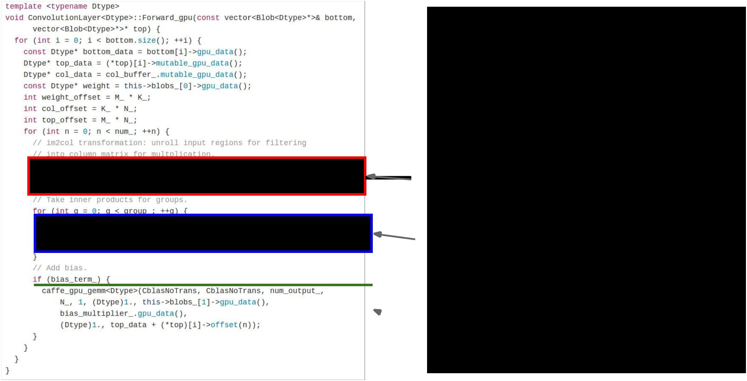Case study:

**CONV forward in Caffe library**

im2col

matrix multiply: call to cuBLAS

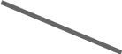 bias offset



Fei-Fei Li & Andrej Karpathy & Justin Johnson Lecture 11 73 17 Feb 2016

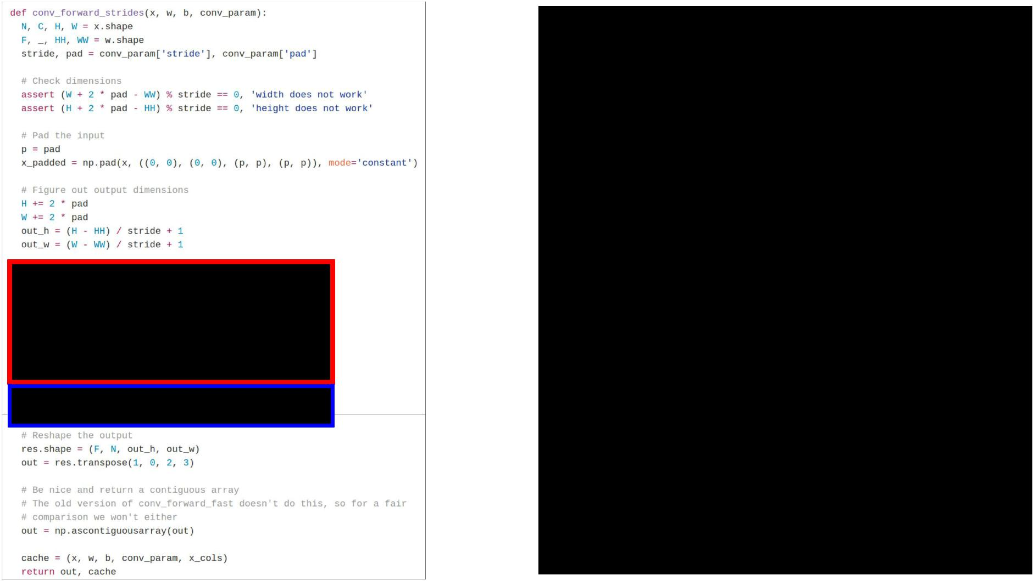Case study:

**fast_layers.py from HW**

im2col

matrix multiply:

call np.dot

(which calls BLAS)



Fei-Fei Li & Andrej Karpathy & Justin Johnson Lecture 11 74 17 Feb 2016

Implementing convolutions: FFT



**Convolution Theorem:** The convolution of f and g is equalto the elementwise product of their Fourier Transforms:

Using the **Fast Fourier Transform**, we can compute the Discrete Fourier transform of an N-dimensional vector in O (N log N) time (also extends to 2D images)



Fei-Fei Li & Andrej Karpathy & Justin Johnson Lecture 11 75 17 Feb 2016

Implementing convolutions: FFT



1. Compute FFT of weights: F(W)
2. Compute FFT of image: F(X)
3. Compute elementwise product: F(W) ○ F(X)
4. Compute inverse FFT: Y = F-1(F(W) ○ F(X))



Fei-Fei Li & Andrej Karpathy & Justin Johnson Lecture 11 76 17 Feb 2016

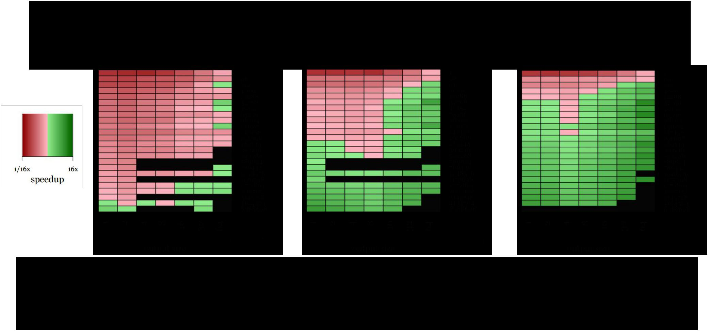Implementing convolutions: FFT

FFT convolutions get a big speedup for larger filters Not much speedup for 3x3 filters =(

Vasilache et al, Fast Convolutional Nets With fbfft: A GPU Performance Evaluation



Fei-Fei Li & Andrej Karpathy & Justin Johnson Lecture 11 77 17 Feb 2016

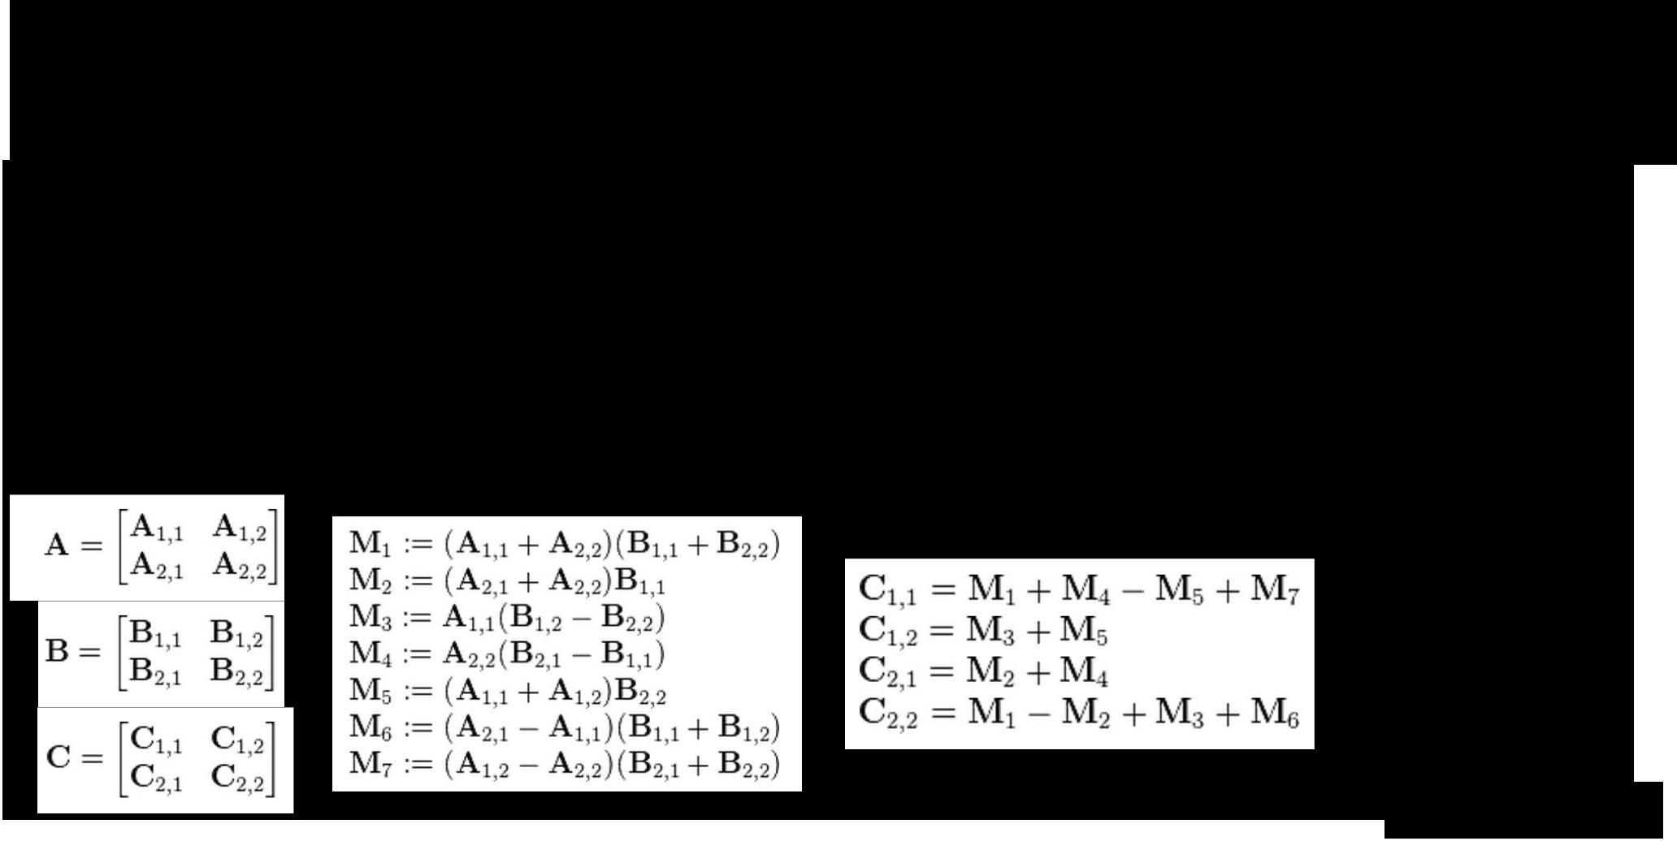Implementing convolution: “Fast Algorithms”

**Naive matrix multiplication**: Computing product of twoN x N matrices takes O(N3) operations

**Strassen’s Algorithm**: Use clever arithmetic to reducecomplexity to O(Nlog2(7)) ~ O(N2.81)

From Wikipedia



Fei-Fei Li & Andrej Karpathy & Justin Johnson Lecture 11 78 17 Feb 2016

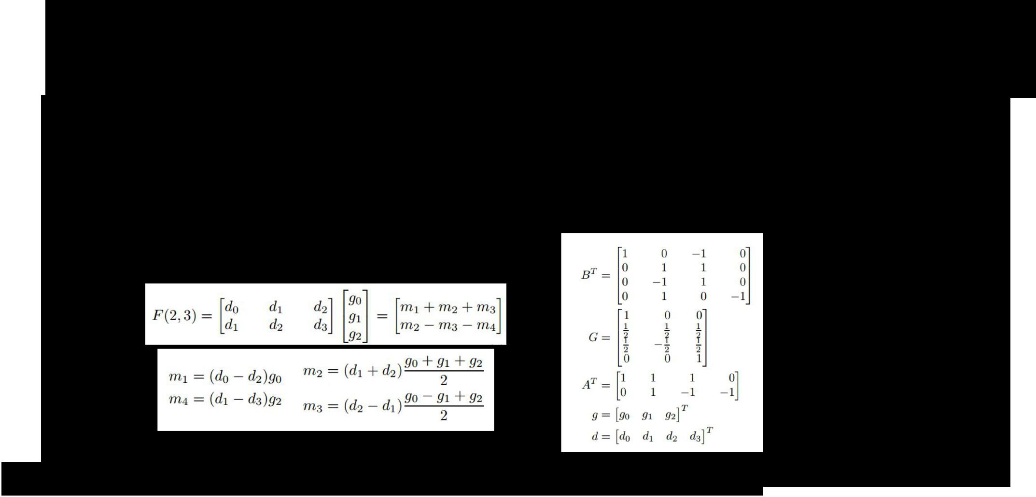Implementing convolution: “Fast Algorithms”

Similar cleverness can be applied to convolutions

Lavin and Gray (2015) work out special cases for 3x3 convolutions:

Lavin and Gray, “Fast Algorithms for Convolutional Neural Networks”, 2015



Fei-Fei Li & Andrej Karpathy & Justin Johnson Lecture 11 79 17 Feb 2016

Implementing convolution: “Fast Algorithms”

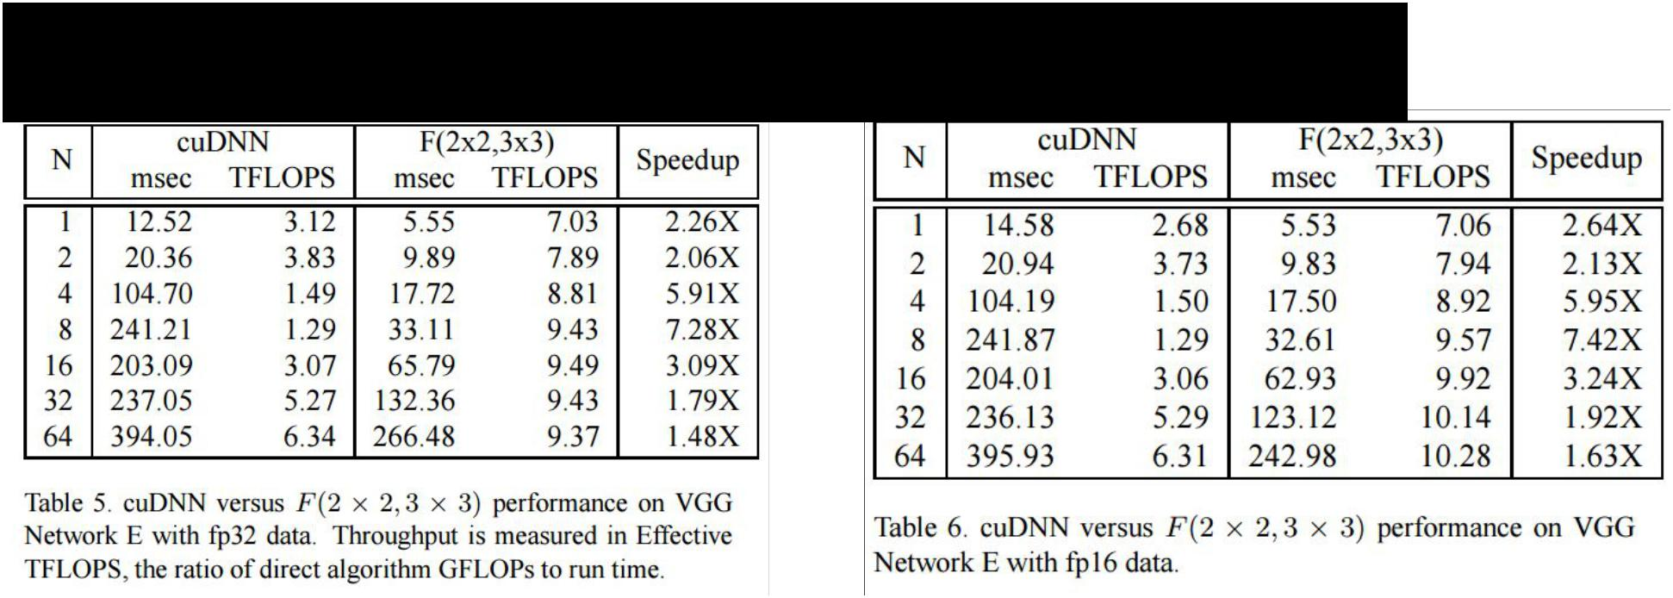

Huge speedups on VGG for small batches:



Fei-Fei Li & Andrej Karpathy & Justin Johnson Lecture 11 80 17 Feb 2016

Computing Convolutions: Recap



* im2col: Easy to implement, but big memory overhead
* FFT: Big speedups for small kernels
* “Fast Algorithms” seem promising, not widely used yet



Fei-Fei Li & Andrej Karpathy & Justin Johnson Lecture 11 81 17 Feb 2016

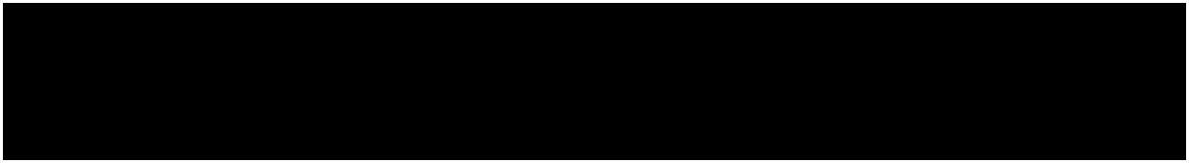

Implementation Details



Fei-Fei Li & Andrej Karpathy & Justin Johnson Lecture 11 82 17 Feb 2016

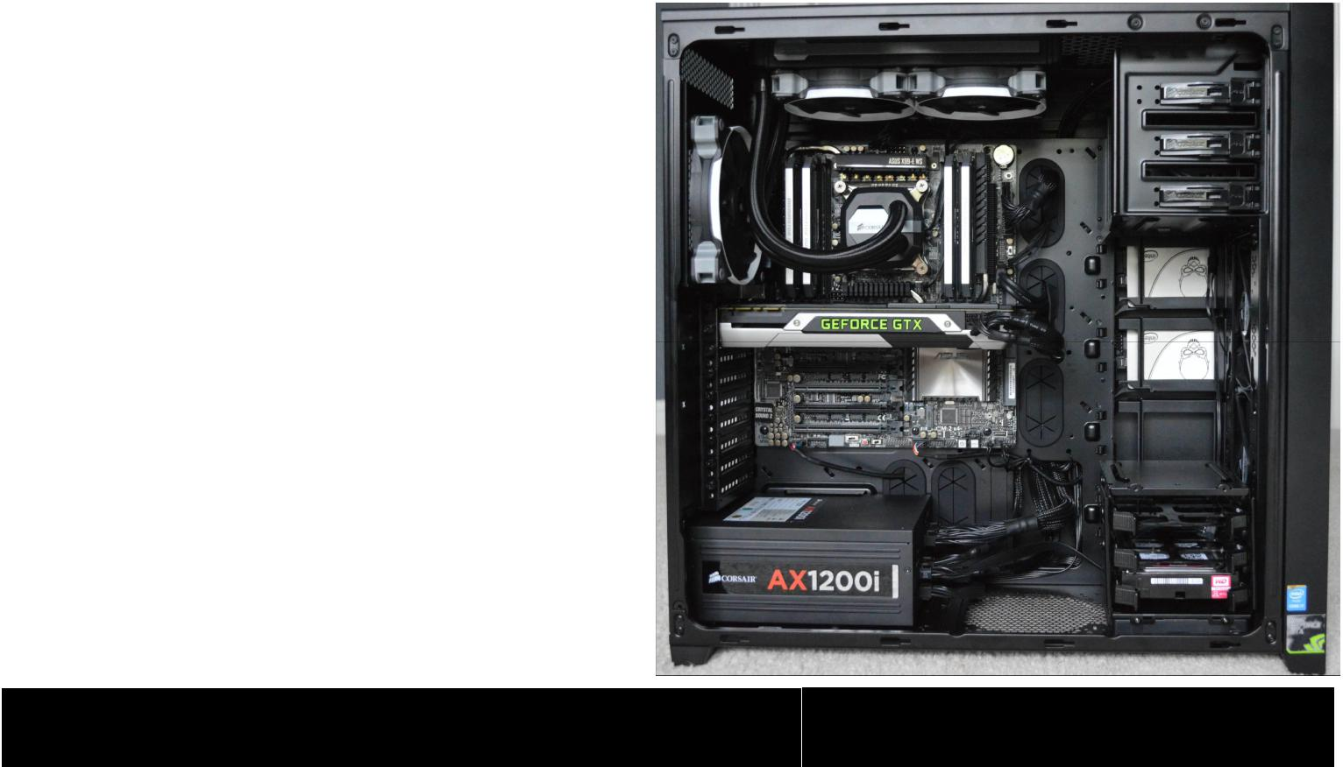

|  |  |  |
| --- | --- | --- |
| Fei-Fei Li & Andrej Karpathy & Justin Johnson | Lecture 11 83 | 17 Feb 2016 |
|  |  |  |

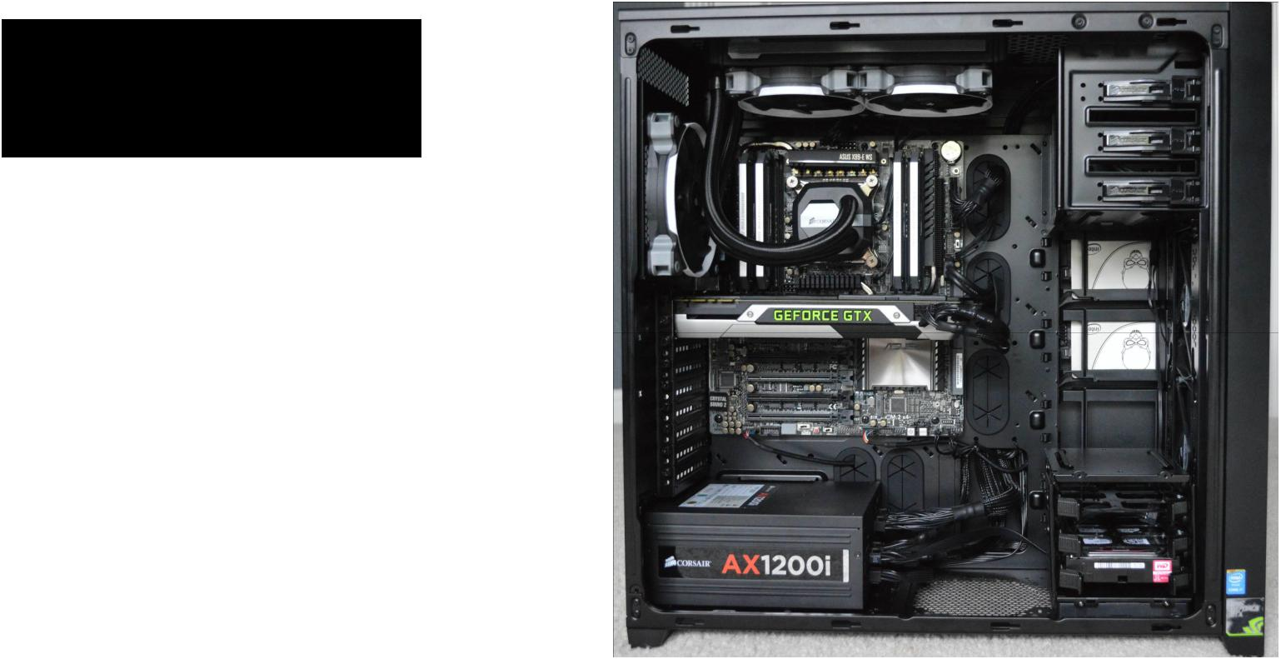Spot the CPU!



Fei-Fei Li & Andrej Karpathy & Justin Johnson Lecture 11 84 17 Feb 2016

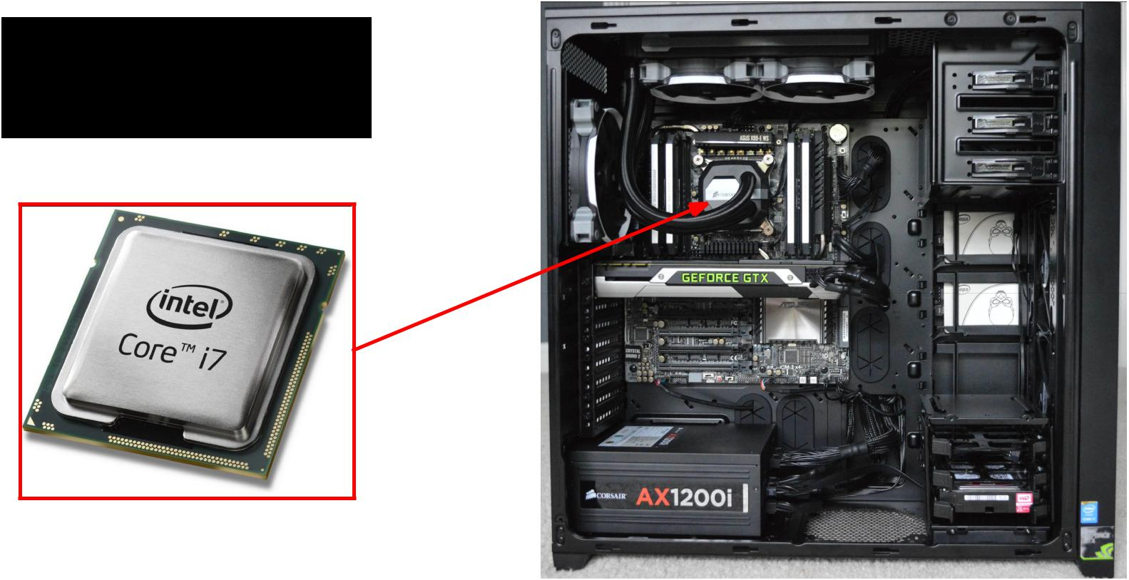Spot the CPU!

“central processing unit”



Fei-Fei Li & Andrej Karpathy & Justin Johnson Lecture 11 85 17 Feb 2016

Spot the GPU!

“graphics processing unit”



Fei-Fei Li & Andrej Karpathy & Justin Johnson Lecture 11 86 17 Feb 2016

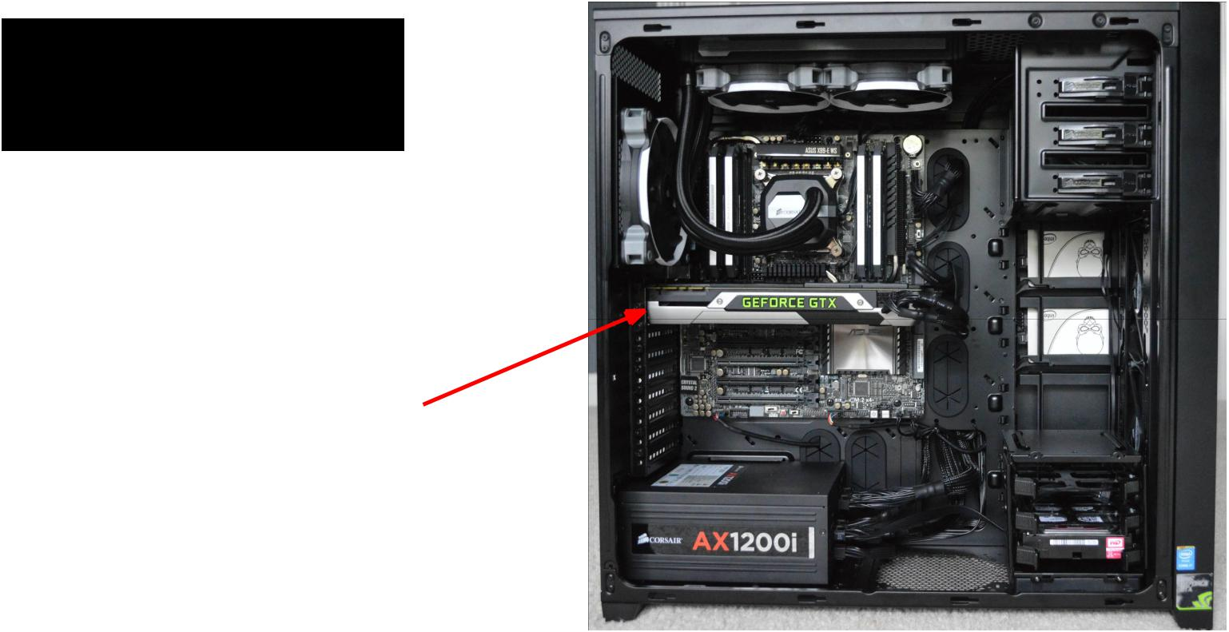Spot the GPU!

“graphics processing unit”

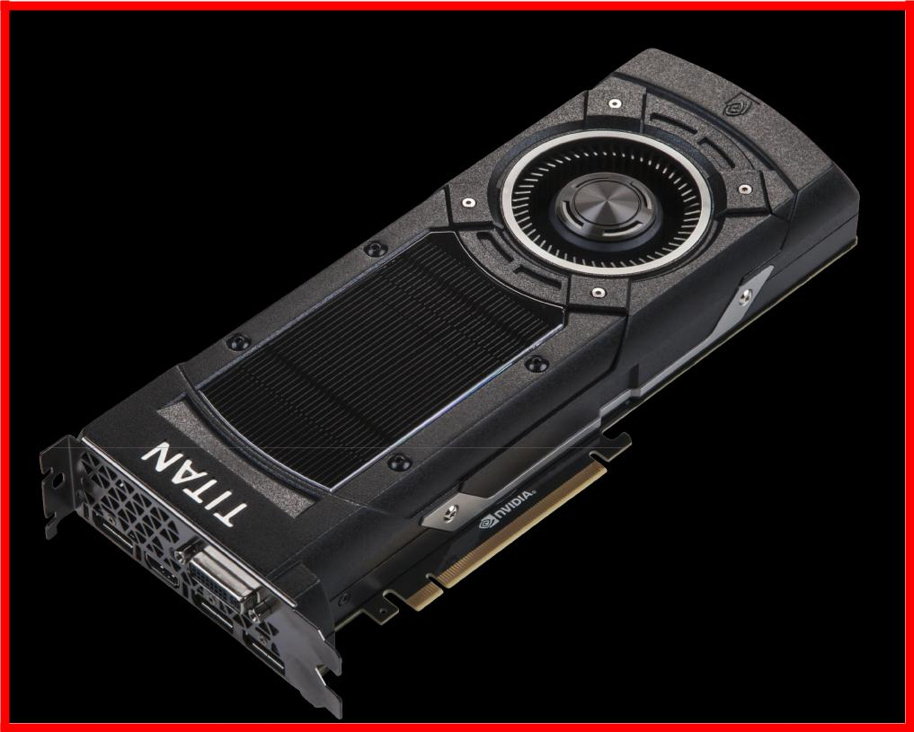

Fei-Fei Li & Andrej Karpathy & Justin Johnson Lecture 11 87 17 Feb 2016



VS



Fei-Fei Li & Andrej Karpathy & Justin Johnson Lecture 11 88 17 Feb 2016



VS



NVIDIA is much more

common for deep learning



Fei-Fei Li & Andrej Karpathy & Justin Johnson Lecture 11 89 17 Feb 2016

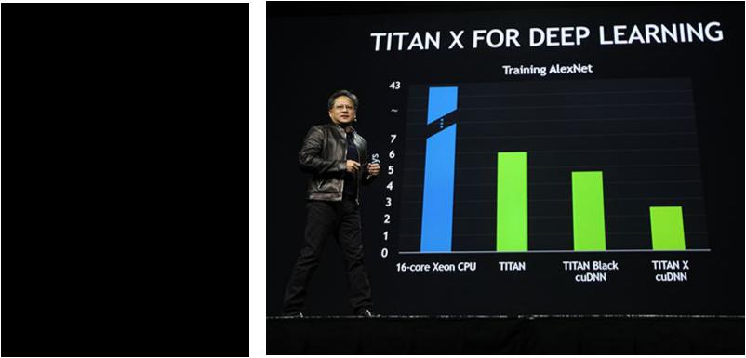**CEO of NVIDIA:**

Jen-Hsun Huang

(Stanford EE Masters 1992)

**GTC 2015:**

Introduced new Titan X GPU by bragging about AlexNet benchmarks



Fei-Fei Li & Andrej Karpathy & Justin Johnson Lecture 11 90 17 Feb 2016

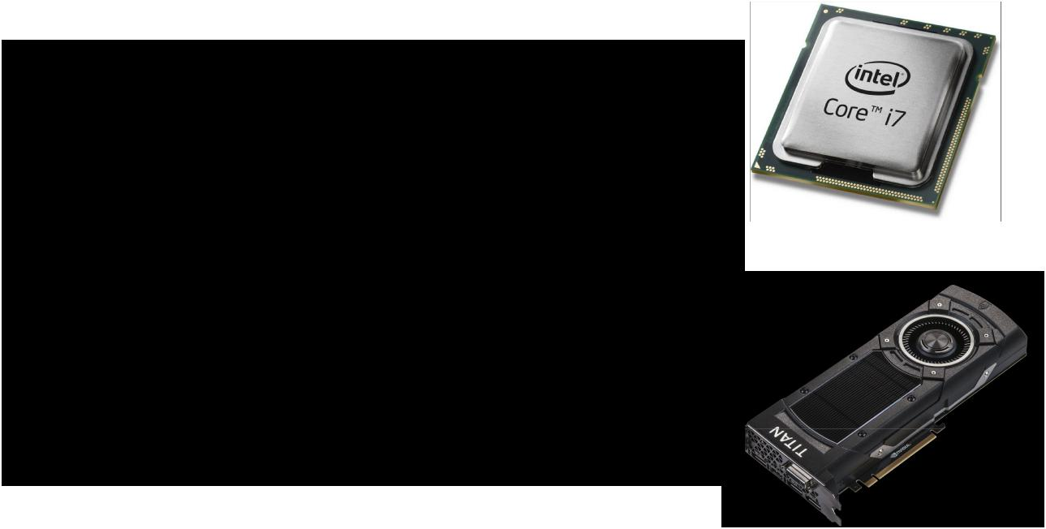**CPU**

Few, fast cores (1 - 16)

Good at sequential processing

**GPU**

Many, slower cores (thousands)

Originally for graphics

Good at parallel computation



Fei-Fei Li & Andrej Karpathy & Justin Johnson Lecture 11 91 17 Feb 2016

GPUs can be programmed



* CUDA (NVIDIA only)
  + Write C code that runs directly on the GPU
  + Higher-level APIs: cuBLAS, cuFFT, cuDNN, etc
* OpenCL
  + Similar to CUDA, but runs on anything
  + Usually slower :(
* Udacity: Intro to Parallel Programming [https://www.udacity.](https://www.udacity.com/course/cs344) [com/course/cs344](https://www.udacity.com/course/cs344)
  + For deep learning just use existing libraries



Fei-Fei Li & Andrej Karpathy & Justin Johnson Lecture 11 92 17 Feb 2016

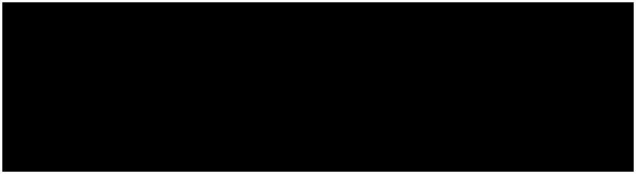GPUs are really good

at matrix multiplication:

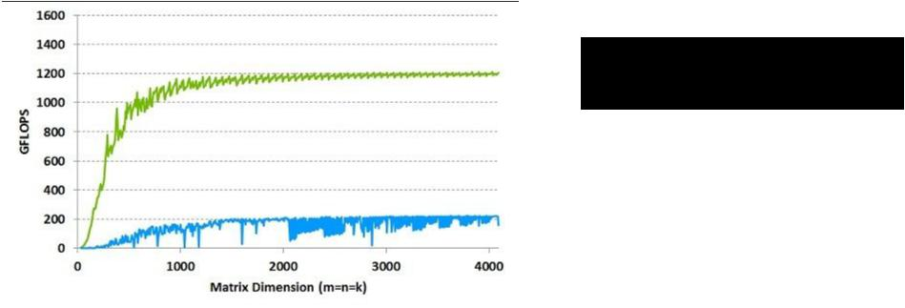

 **GPU**: NVIDA Tesla K40



with cuBLAS

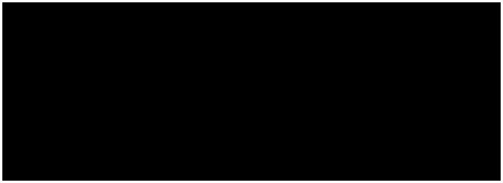

**CPU**: Intel E5-2697 v2

12 core @ 2.7 Ghz



with MKL



Fei-Fei Li & Andrej Karpathy & Justin Johnson Lecture 11 93 17 Feb 2016

GPUs are really good at convolution (cuDNN):

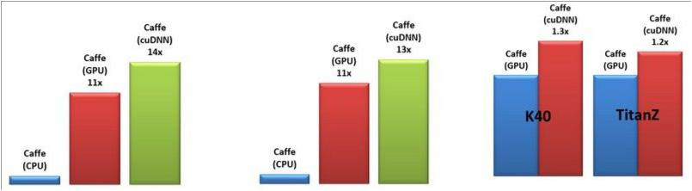

All comparisons are against a 12-core Intel E5-2679v2 CPU @ 2.4GHz running Caffe with Intel MKL 11.1.3.



Fei-Fei Li & Andrej Karpathy & Justin Johnson Lecture 11 94 17 Feb 2016

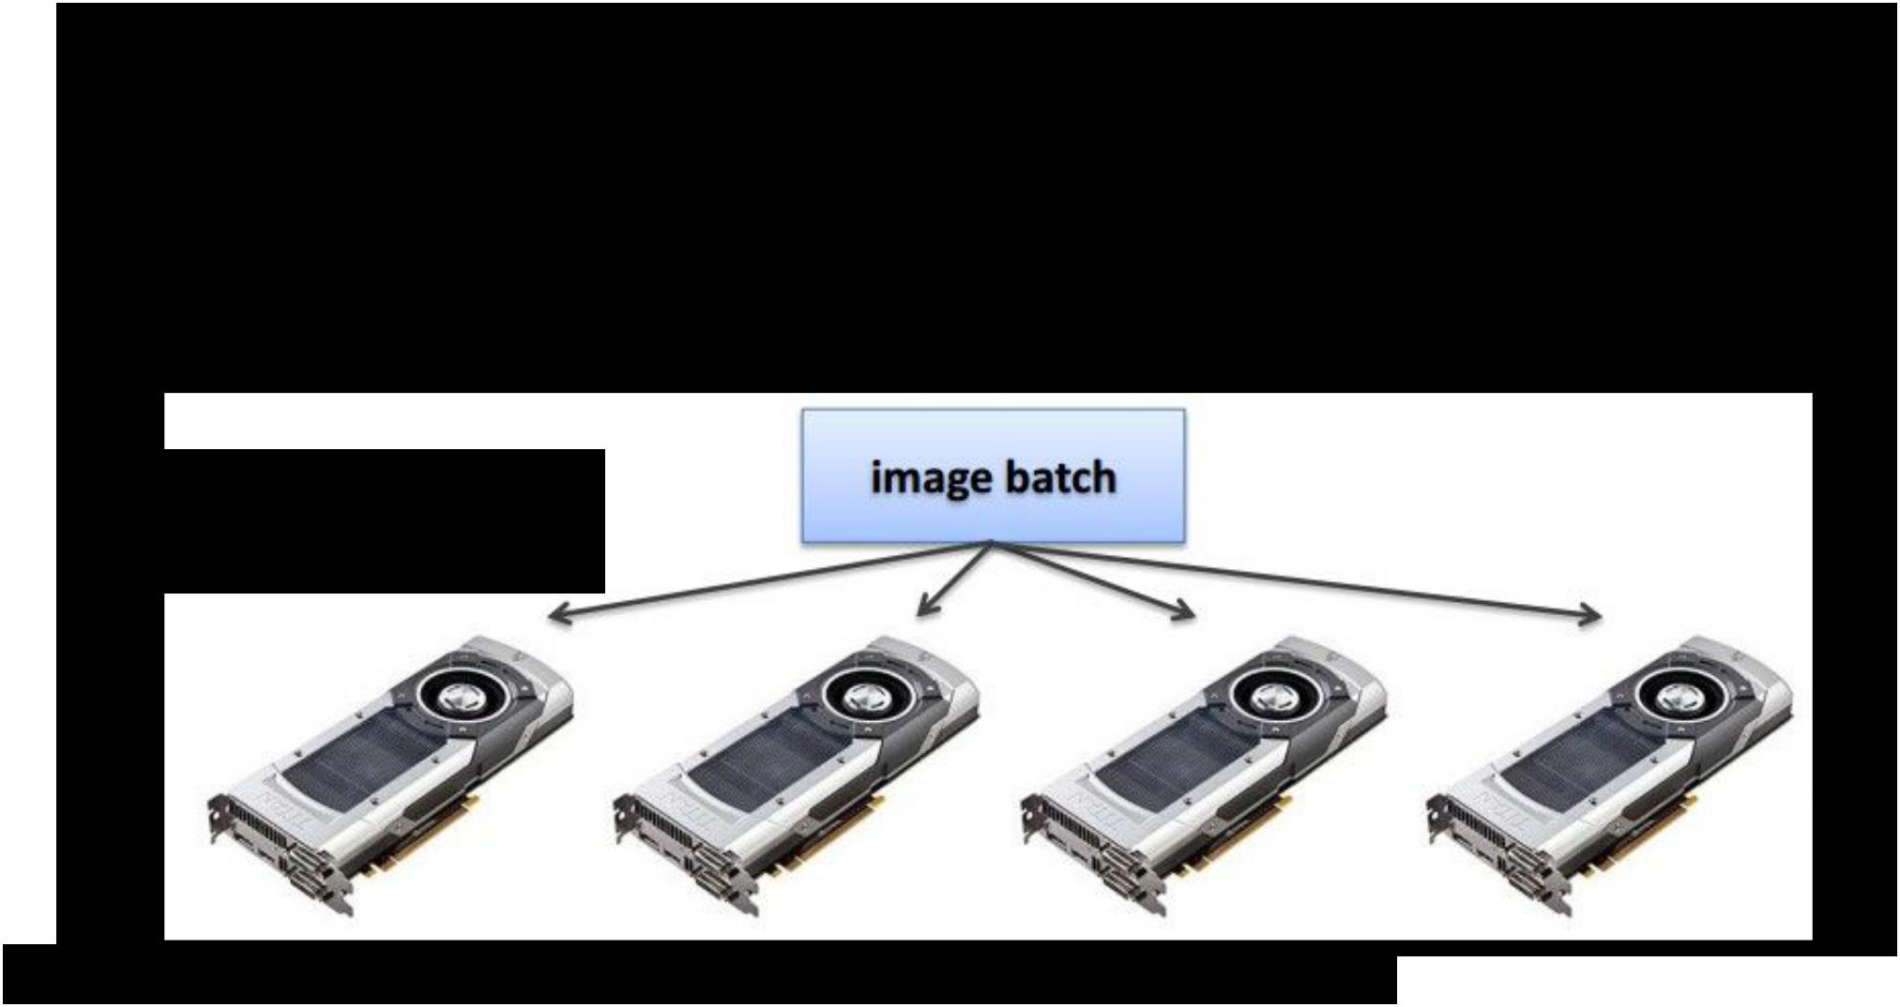Even with GPUs, training can be slow

**VGG: ~**2-3 weeks training with 4 GPUs

**ResNet 101:** 2-3 weeks with 4 GPUs

NVIDIA Titan Blacks

~$1K each

ResNet reimplemented in Torch: <http://torch.ch/blog/2016/02/04/resnets.html>



Fei-Fei Li & Andrej Karpathy & Justin Johnson Lecture 11 95 17 Feb 2016

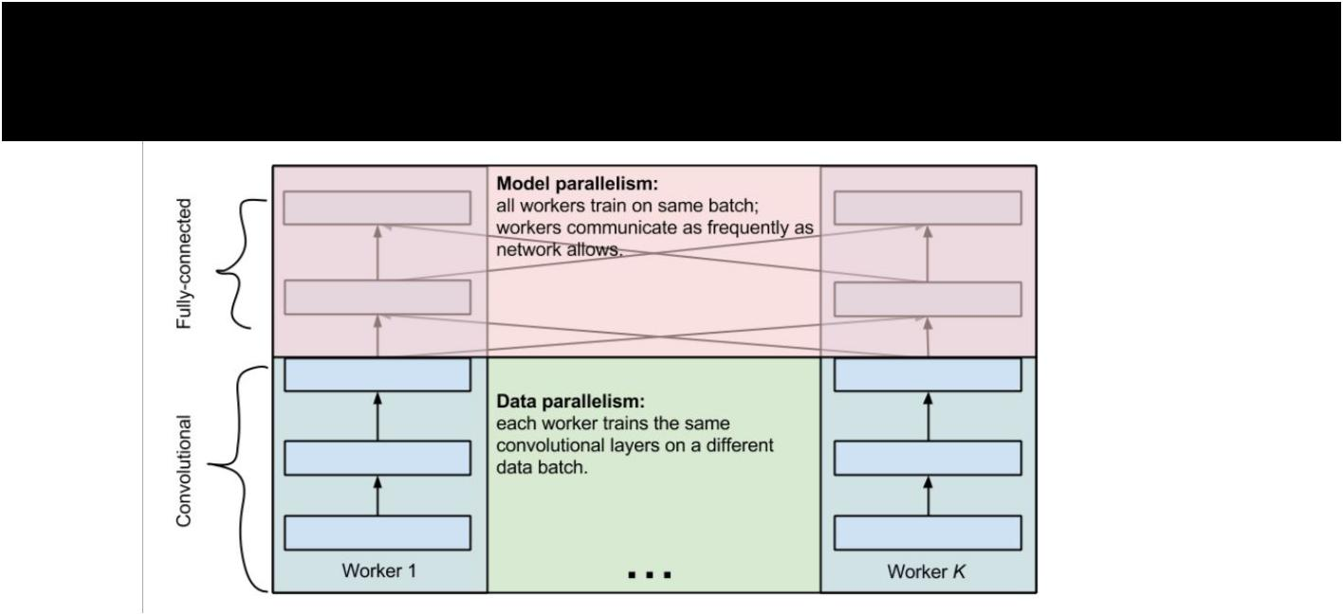Multi-GPU training: More complex



Alex Krizhevsky, “One weird trick for parallelizing convolutional neural networks”



Fei-Fei Li & Andrej Karpathy & Justin Johnson Lecture 11 96 17 Feb 2016

Google: Distributed CPU training

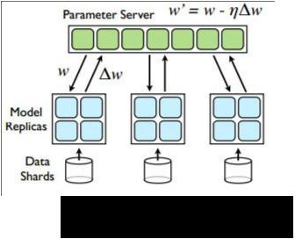

**Data parallelism**



*[Large Scale Distributed Deep Networks, Jeff Dean et al., 2013]*



Fei-Fei Li & Andrej Karpathy & Justin Johnson Lecture 11 97 17 Feb 2016

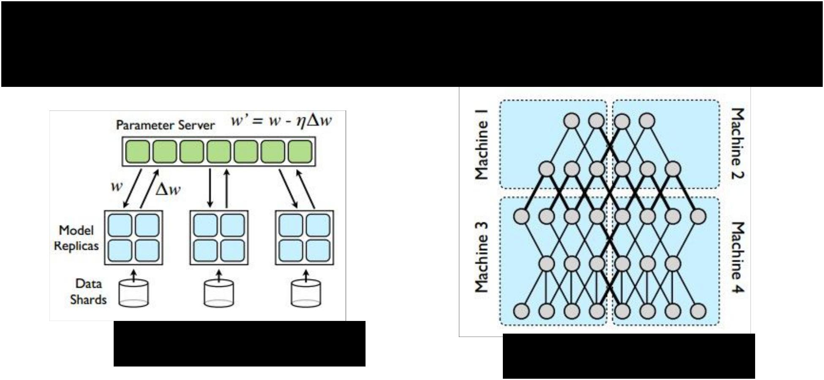Google: Distributed CPU training

|  |  |  |
| --- | --- | --- |
| **Data parallelism** | **Model parallelism** |  |
|  |  |



*[Large Scale Distributed Deep Networks, Jeff Dean et al., 2013]*



Fei-Fei Li & Andrej Karpathy & Justin Johnson Lecture 11 98 17 Feb 2016

Google: Synchronous vs Async

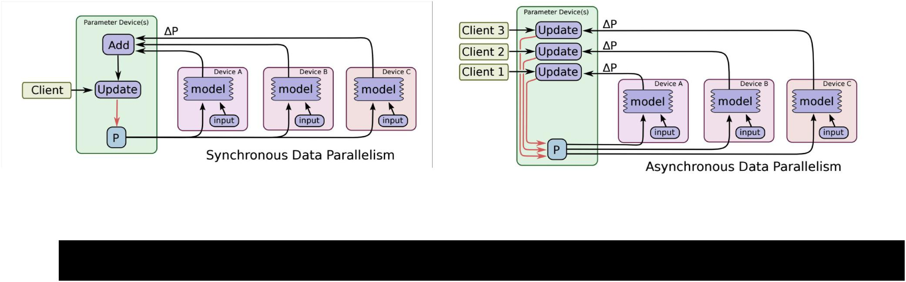

*Abadi et al, “TensorFlow: Large-Scale Machine Learning on Heterogeneous Distributed Systems”*



Fei-Fei Li & Andrej Karpathy & Justin Johnson Lecture 11 99 17 Feb 2016



Bottlenecks

to be aware of

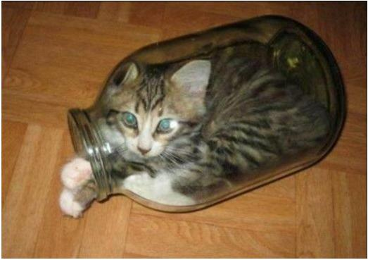

|  |  |  |  |
| --- | --- | --- | --- |
| Fei-Fei Li & Andrej Karpathy & Justin Johnson | Lecture 11 | 10 | 17 Feb 2016 |
|  |  | 0 |  |



**GPU - CPU communication is a bottleneck.** =>

**CPU** data prefetch+augment thread running

while

**GPU** performs forward/backward pass



|  |  |  |  |
| --- | --- | --- | --- |
| Fei-Fei Li & Andrej Karpathy & Justin Johnson | Lecture 11 | 10 | 17 Feb 2016 |
|  |  | 1 |  |

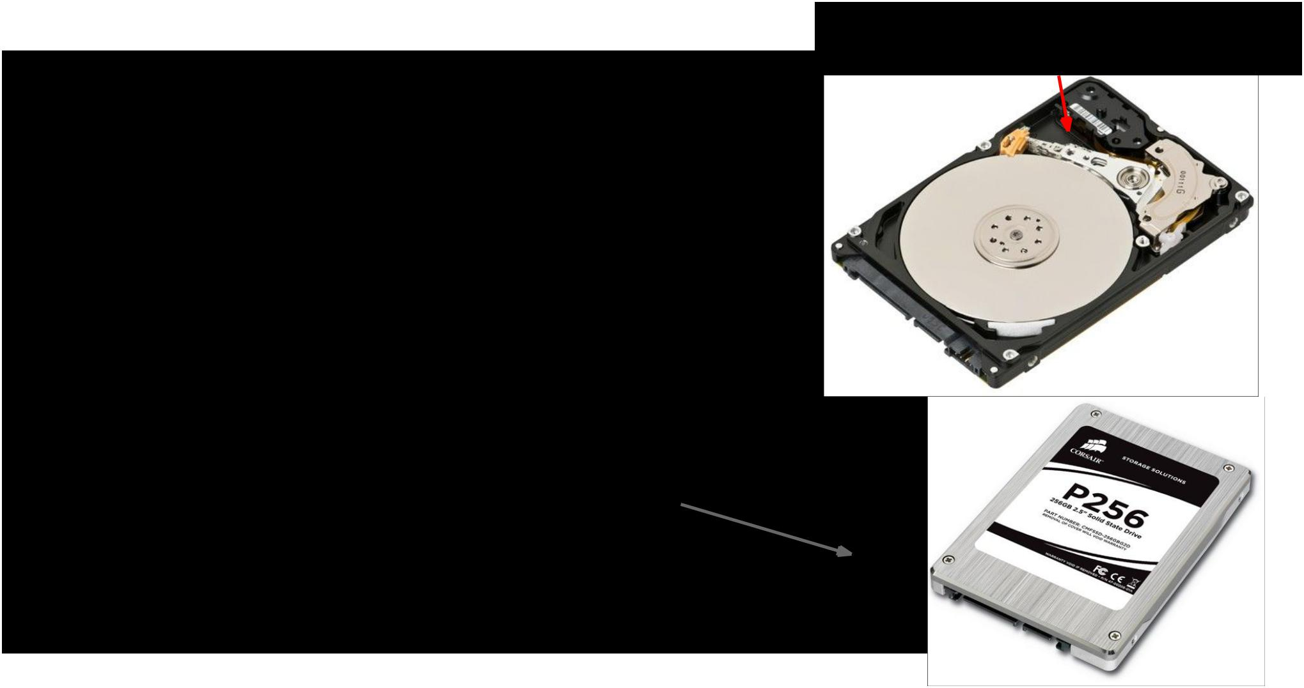

Moving parts lol

**CPU - disk bottleneck**

Hard disk is slow to read from

=> Pre-processed images

stored contiguously in files, read as raw byte stream from SSD disk



|  |  |  |  |
| --- | --- | --- | --- |
| Fei-Fei Li & Andrej Karpathy & Justin Johnson | Lecture 11 | 10 | 17 Feb 2016 |
|  |  | 2 |  |



**GPU memory bottleneck**

Titan X: 12 GB <- currently the max

GTX 980 Ti: 6 GB

e.g.

AlexNet: ~3GB needed with batch size 256



|  |  |  |  |
| --- | --- | --- | --- |
| Fei-Fei Li & Andrej Karpathy & Justin Johnson | Lecture 11 | 10 | 17 Feb 2016 |
|  |  | 3 |  |



Floating Point Precision



|  |  |  |  |
| --- | --- | --- | --- |
| Fei-Fei Li & Andrej Karpathy & Justin Johnson | Lecture 11 | 10 | 17 Feb 2016 |
|  |  | 4 |  |



Floating point precision

* 64 bit “double” precision is default in a lot of programming
* 32 bit “single” precision is typically used for CNNs for performance



|  |  |  |  |
| --- | --- | --- | --- |
| Fei-Fei Li & Andrej Karpathy & Justin Johnson | Lecture 11 | 10 | 17 Feb 2016 |
|  |  | 5 |  |

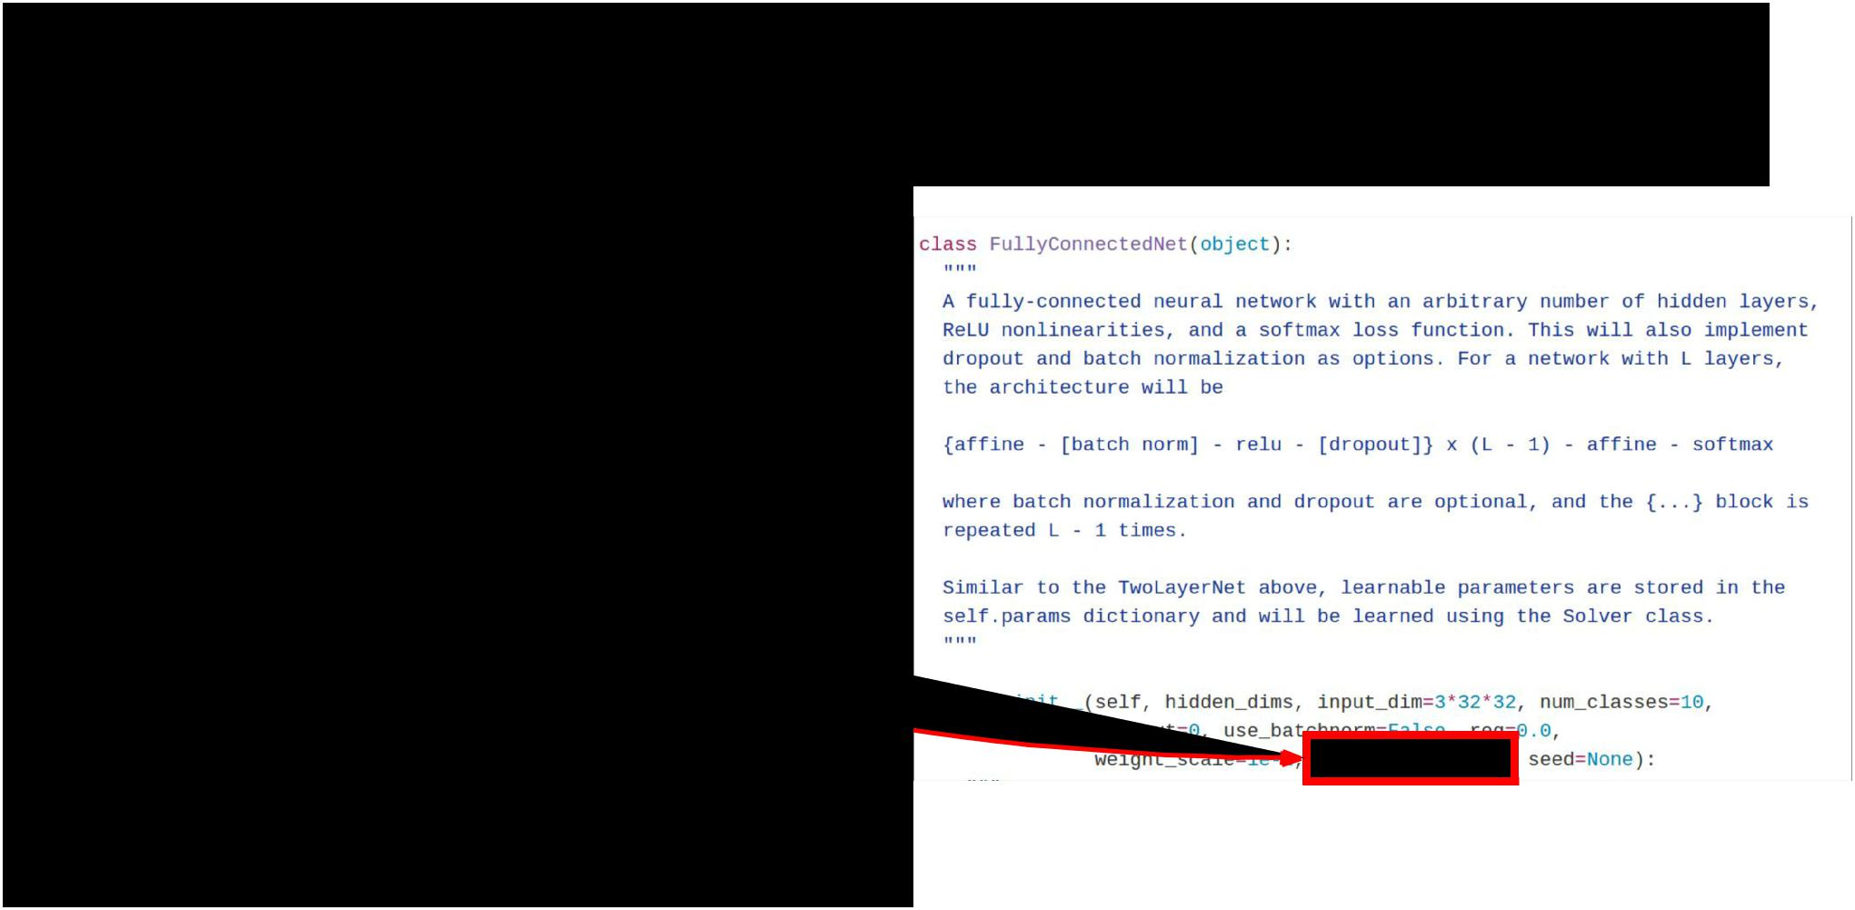

Floating point precision

* 64 bit “double” precision is default in a lot of programming
* 32 bit “single” precision is typically used for CNNs for performance
  + Including cs231n homework!



|  |  |  |  |
| --- | --- | --- | --- |
| Fei-Fei Li & Andrej Karpathy & Justin Johnson | Lecture 11 | 10 | 17 Feb 2016 |
|  |  | 6 |  |

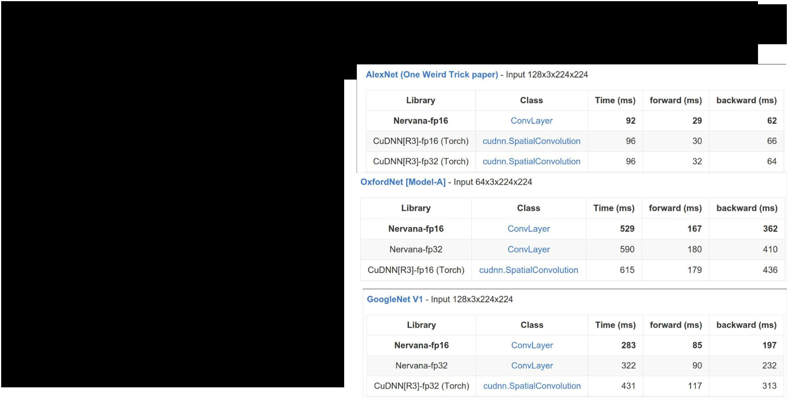

Floating point precision

**Prediction**: 16 bit “half” precisionwill be the new standard

* Already supported in cuDNN
* Nervana fp16 kernels are the fastest right now
* Hardware support in next-gen NVIDIA cards (Pascal)
* Not yet supported in torch =(



Benchmarks on Titan X, from [https://github.](https://github.com/soumith/convnet-benchmarks)

[com/soumith/convnet-benchmarks](https://github.com/soumith/convnet-benchmarks)

|  |  |  |  |
| --- | --- | --- | --- |
| Fei-Fei Li & Andrej Karpathy & Justin Johnson | Lecture 11 | 10 | 17 Feb 2016 |
|  |  | 7 |  |

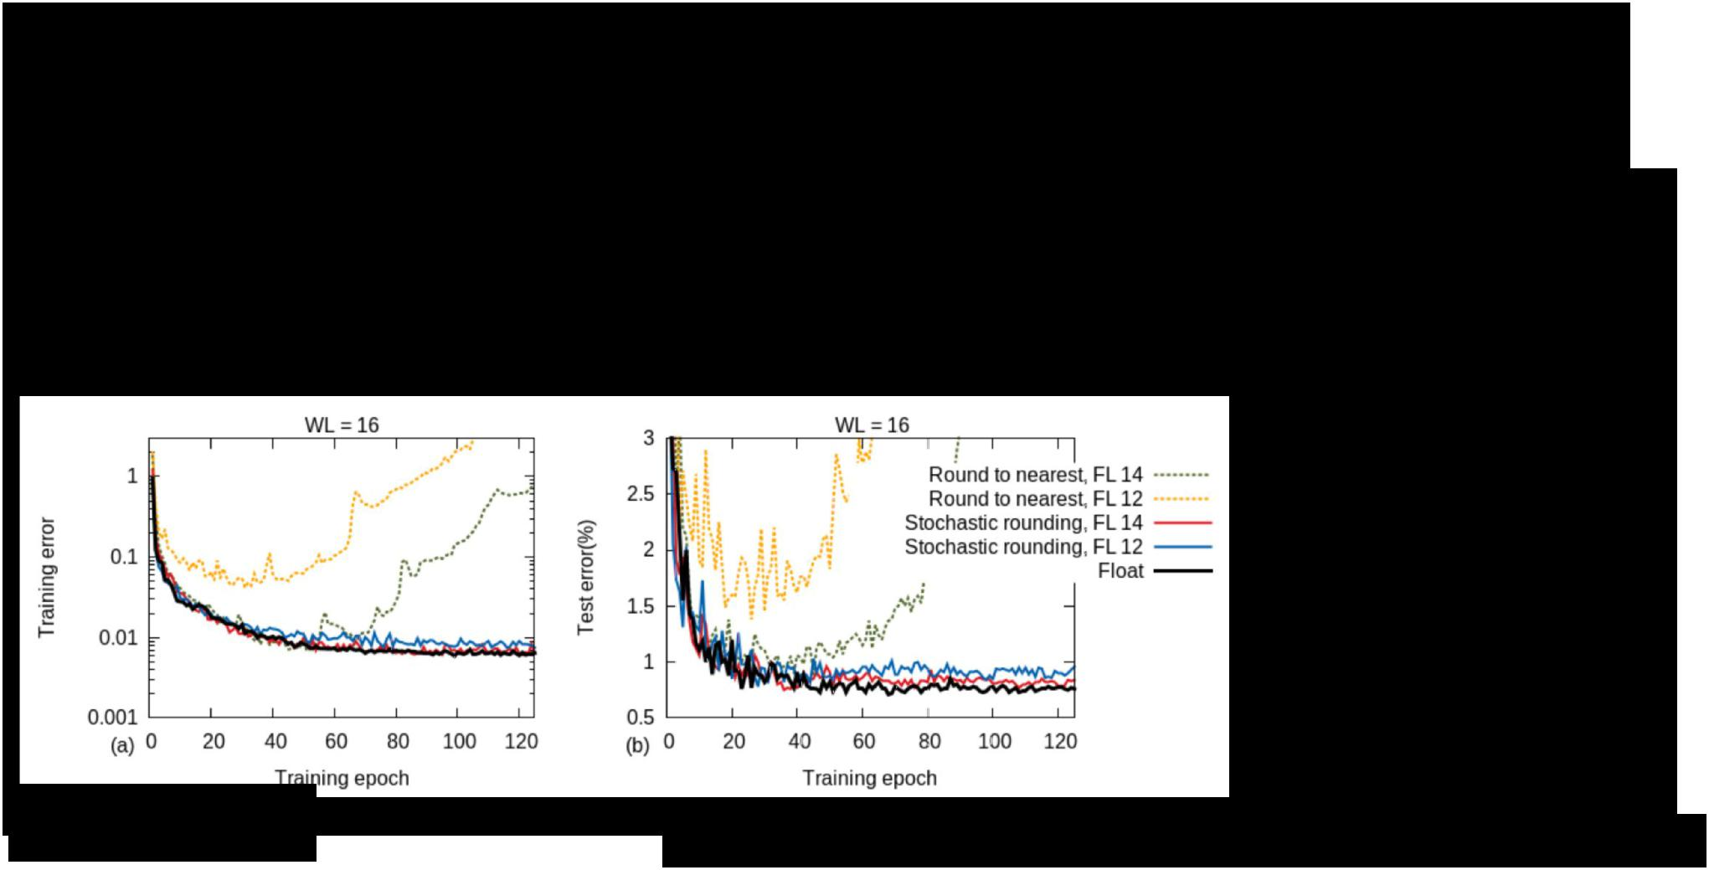

Floating point precision

How low can we go?

Gupta et al, 2015:

Train with **16-bit fixed point** with stochastic rounding

CNNs on MNIST

Gupta et al, “Deep Learning with Limited Numerical Precision”, ICML 2015



|  |  |  |  |
| --- | --- | --- | --- |
| Fei-Fei Li & Andrej Karpathy & Justin Johnson | Lecture 11 | 10 | 17 Feb 2016 |
|  |  | 8 |  |



Floating point precision

How low can we go?

Courbariaux et al, 2015:

Train with **10-bit activations**, **12-bit parameter updates**

|  |  |  |  |  |
| --- | --- | --- | --- | --- |
|  | Courbariaux et al, “Training Deep Neural Networks with Low Precision Multiplications”, ICLR 2015 | | |  |
|  |  |  |  |  |
|  |  |  |  |  |
| Fei-Fei Li & Andrej Karpathy & Justin Johnson | | Lecture 11 | 10 | 17 Feb 2016 |
|  |  |  | 9 |  |





Floating point precision

How low can we go?

Courbariaux and Bengio, February 9 2016:

* Train with **1-bit activations and weights**!
* All activations and weights are +1 or -1
* Fast multiplication with bitwise XNOR
* (Gradients use higher precision)

Courbariaux et al, “BinaryNet: Training Deep Neural Networks with Weights and Activations Constrained to +1 or -1”, arXiv 2016



|  |  |  |  |
| --- | --- | --- | --- |
| Fei-Fei Li & Andrej Karpathy & Justin Johnson | Lecture 11 | 11 | 17 Feb 2016 |
|  |  | 0 |  |



Implementation details: Recap



* GPUs much faster than CPUs
* Distributed training is sometimes used
  + Not needed for small problems
* Be aware of bottlenecks: CPU / GPU, CPU / disk
* Low precison makes things faster and still works
  + 32 bit is standard now, 16 bit soon
  + In the future: binary nets?



|  |  |  |  |
| --- | --- | --- | --- |
| Fei-Fei Li & Andrej Karpathy & Justin Johnson | Lecture 11 | 11 | 17 Feb 2016 |
|  |  | 1 |  |



Recap



* Data augmentation: artificially expand your data
* Transfer learning: CNNs without huge data
* All about convolutions
* Implementation details



|  |  |  |  |
| --- | --- | --- | --- |
| Fei-Fei Li & Andrej Karpathy & Justin Johnson | Lecture 11 | 11 | 17 Feb 2016 |
|  |  | 2 |  |